Assignment 3

1] MongoDB Enterprise atlas-z8cl0o-shard-0:PRIMARY>

db.addresses.find().pretty()

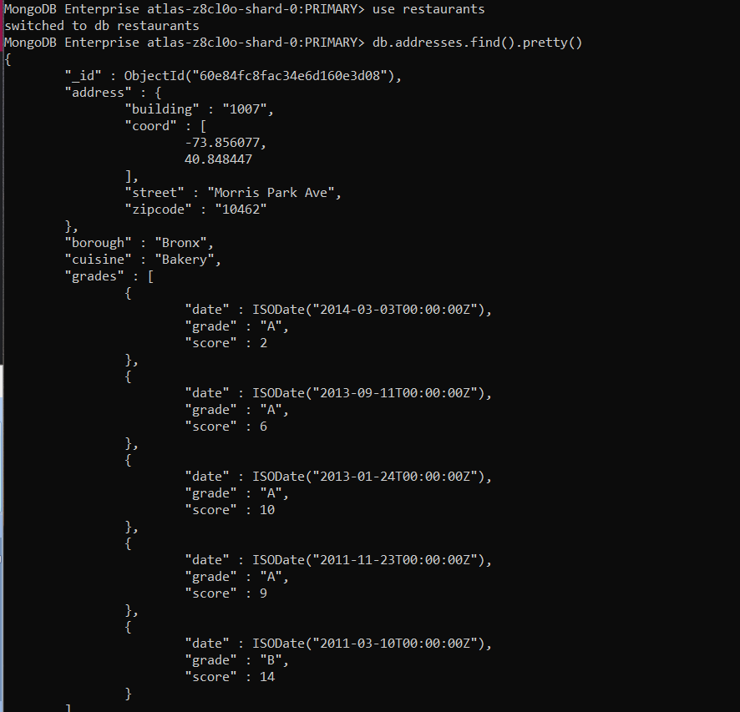

2] MongoDB Enterprise atlas-z8cl0o-shard-0:PRIMARY> db.addresses.find({},{"restaurant_id":1,"name":1,"borough":1,"cuisine":1});

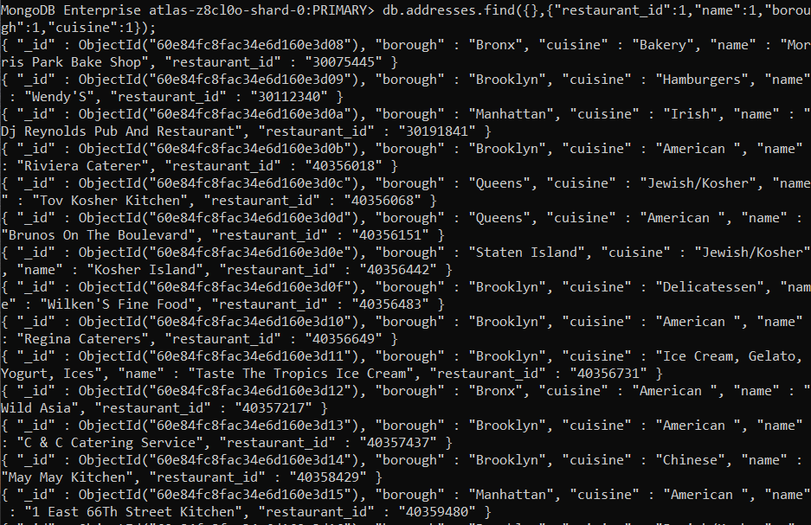

3] MongoDB Enterprise atlas-z8cl0o-shard-0:PRIMARY> db.addresses.find({},{"restaurant_id":1,"name":1,"borough":1,"cuisine":1,"_id":0});

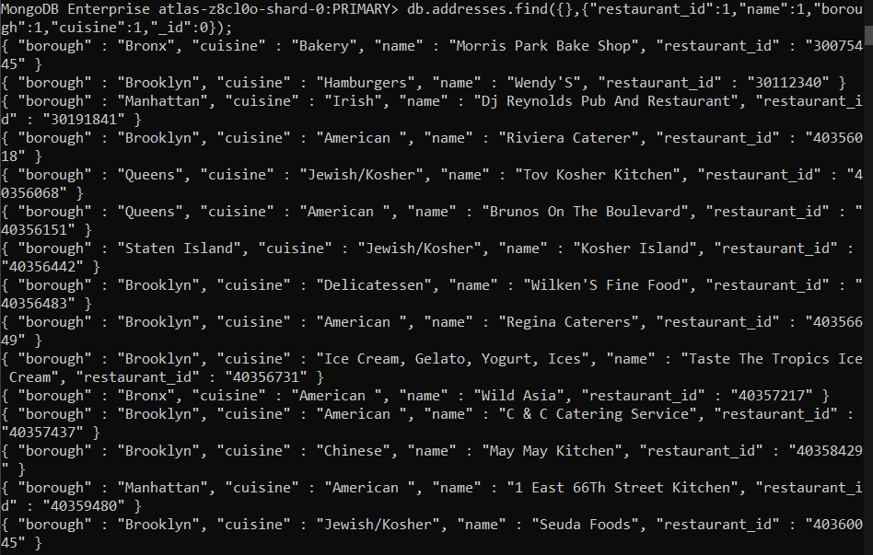

4] MongoDB Enterprise atlas-z8cl0o-shard-0:PRIMARY> db.addresses.find({},{"restaurant_id":1,"name":1,"borough":1,"address.zipcode":1,"_id":0});

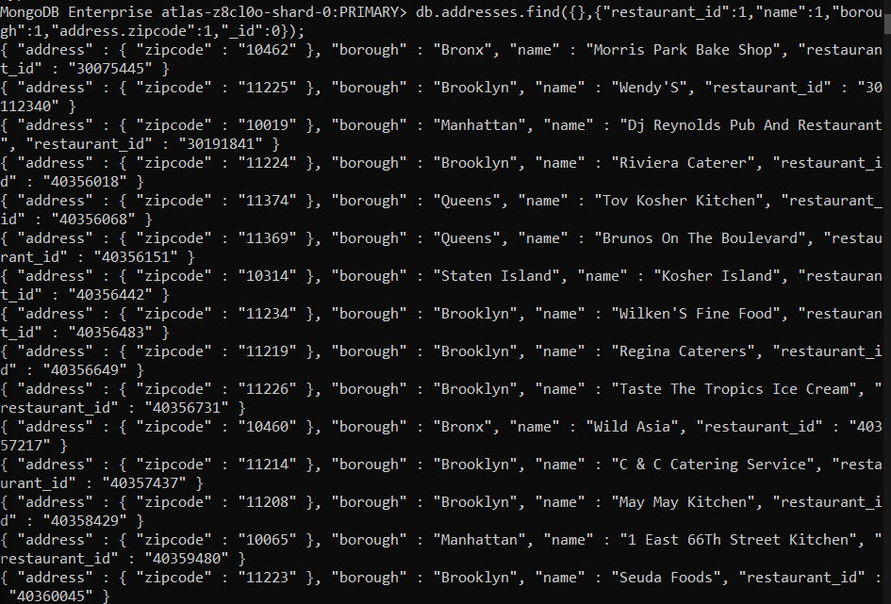

5] MongoDB Enterprise atlas-z8cl0o-shard-0:PRIMARY>

db.addresses.aggregate({$match:{"borough":"Bronx"}},{$limit:5}).pretty()

{

"_id" : ObjectId("60e7d37a51ca61afa332d3c6"),

"address" : {

"building" : "1007",

"coord" : [

-73.856077,

40.848447

],

"street" : "Morris Park Ave",

"zipcode" : "10462"

},

"borough" : "Bronx",

"cuisine" : "Bakery",

"grades" : [

{

"date" : ISODate("2014-03-03T00:00:00Z"),

"grade" : "A",

"score" : 2

},

{

"date" : ISODate("2013-09-11T00:00:00Z"),

"grade" : "A",

"score" : 6

},

{

"date" : ISODate("2013-01-24T00:00:00Z"),

"grade" : "A",

"score" : 10

},

{

"date" : ISODate("2011-11-23T00:00:00Z"),

"grade" : "A",

"score" : 9

},

{

"date" : ISODate("2011-03-10T00:00:00Z"),

"grade" : "B",

"score" : 14

}

],

"name" : "Morris Park Bake Shop",

"restaurant_id" : "30075445"

}

{

"_id" : ObjectId("60e7d37a51ca61afa332d3d0"),

"address" : {

"building" : "2300",

"coord" : [

-73.8786113,

40.8502883

],

"street" : "Southern Boulevard",

"zipcode" : "10460"

},

"borough" : "Bronx",

"cuisine" : "American ",

"grades" : [

{

"date" : ISODate("2014-05-28T00:00:00Z"),

"grade" : "A",

"score" : 11

},

{

"date" : ISODate("2013-06-19T00:00:00Z"),

"grade" : "A",

"score" : 4

},

{

"date" : ISODate("2012-06-15T00:00:00Z"),

"grade" : "A",

"score" : 3

}

],

"name" : "Wild Asia",

"restaurant_id" : "40357217"

}

{

"_id" : ObjectId("60e7d37a51ca61afa332d3e5"),

"address" : {

"building" : "1006",

"coord" : [

-73.84856870000002,

40.8903781

],

"street" : "East 233 Street",

"zipcode" : "10466"

},

"borough" : "Bronx",

"cuisine" : "Ice Cream, Gelato, Yogurt, Ices",

"grades" : [

{

"date" : ISODate("2014-04-24T00:00:00Z"),

"grade" : "A",

"score" : 10

},

{

"date" : ISODate("2013-09-05T00:00:00Z"),

"grade" : "A",

"score" : 10

},

{

"date" : ISODate("2013-02-21T00:00:00Z"),

"grade" : "A",

"score" : 9

},

{

"date" : ISODate("2012-07-03T00:00:00Z"),

"grade" : "A",

"score" : 11

},

{

"date" : ISODate("2011-07-11T00:00:00Z"),

"grade" : "A",

"score" : 5

}

],

"name" : "Carvel Ice Cream",

"restaurant_id" : "40363093"

}

{

"_id" : ObjectId("60e7d37a51ca61afa332d3e9"),

"address" : {

"building" : "1236",

"coord" : [

-73.8893654,

40.81376179999999

],

"street" : "238 Spofford Ave",

"zipcode" : "10474"

},

"borough" : "Bronx",

"cuisine" : "Chinese",

"grades" : [

{

"date" : ISODate("2013-12-30T00:00:00Z"),

"grade" : "A",

"score" : 8

},

{

"date" : ISODate("2013-01-08T00:00:00Z"),

"grade" : "A",

"score" : 10

},

{

"date" : ISODate("2012-06-12T00:00:00Z"),

"grade" : "B",

"score" : 15

}

],

"name" : "Happy Garden",

"restaurant_id" : "40363289"

}

{

"_id" : ObjectId("60e7d37a51ca61afa332d3fb"),

"address" : {

"building" : "277",

"coord" : [

-73.8941893,

40.8634684

],

"street" : "East Kingsbridge Road",

"zipcode" : "10458"

},

"borough" : "Bronx",

"cuisine" : "Chinese",

"grades" : [

{

"date" : ISODate("2014-03-03T00:00:00Z"),

"grade" : "A",

"score" : 10

},

{

"date" : ISODate("2013-09-26T00:00:00Z"),

"grade" : "A",

"score" : 10

},

{

"date" : ISODate("2013-03-19T00:00:00Z"),

"grade" : "A",

"score" : 10

},

{

"date" : ISODate("2012-08-29T00:00:00Z"),

"grade" : "A",

"score" : 11

},

{

"date" : ISODate("2011-08-17T00:00:00Z"),

"grade" : "A",

"score" : 13

}

],

"name" : "Happy Garden",

"restaurant_id" : "40364296"

}

6] MongoDB Enterprise atlas-z8cl0o-shard-0:PRIMARY>

db.addresses.aggregate({$match:{"borough":"Bronx"}}).pretty()

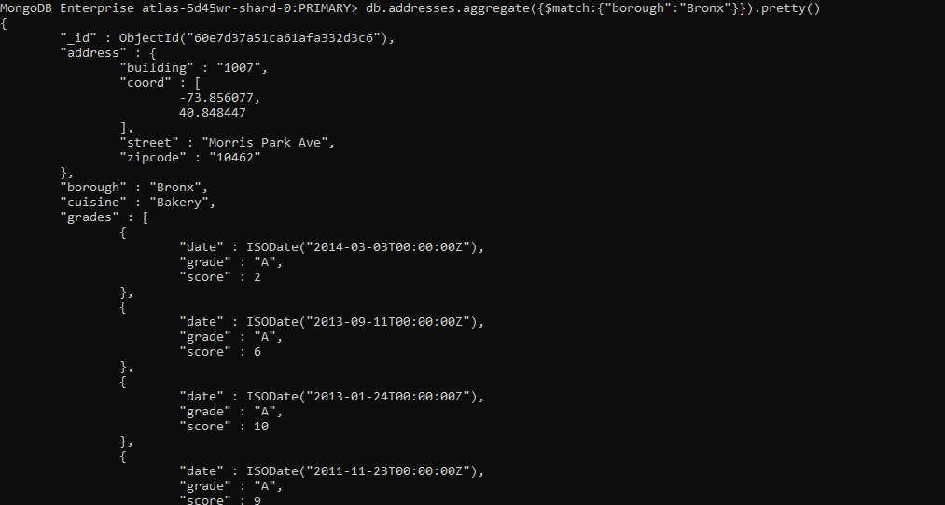

7] db.addresses.aggregate({$match:{"borough":"Bronx"}},{$skip:5},{$limit:5}).pretty()

{

"_id" : ObjectId("60e7d37a51ca61afa332d403"),

"address" : {

"building" : "658",

"coord" : [

-73.81363999999999,

40.82941100000001

],

"street" : "Clarence Ave",

"zipcode" : "10465"

},

"borough" : "Bronx",

"cuisine" : "American ",

"grades" : [

{

"date" : ISODate("2014-06-21T00:00:00Z"),

"grade" : "A",

"score" : 5

},

{

"date" : ISODate("2012-07-11T00:00:00Z"),

"grade" : "A",

"score" : 10

}

],

"name" : "Manhem Club",

"restaurant_id" : "40364363"

}

{

"_id" : ObjectId("60e7d37a51ca61afa332d41b"),

"address" : {

"building" : "2222",

"coord" : [

-73.84971759999999,

40.8304811

],

"street" : "Haviland Avenue",

"zipcode" : "10462"

},

"borough" : "Bronx",

"cuisine" : "American ",

"grades" : [

{

"date" : ISODate("2014-12-18T00:00:00Z"),

"grade" : "A",

"score" : 7

},

{

"date" : ISODate("2014-05-01T00:00:00Z"),

"grade" : "B",

"score" : 17

},

{

"date" : ISODate("2013-03-14T00:00:00Z"),

"grade" : "A",

"score" : 12

},

{

"date" : ISODate("2012-09-20T00:00:00Z"),

"grade" : "A",

"score" : 9

},

{

"date" : ISODate("2012-02-08T00:00:00Z"),

"grade" : "B",

"score" : 19

}

],

"name" : "The New Starling Athletic Club Of The Bronx",

"restaurant_id" : "40364956"

}

{

"_id" : ObjectId("60e7d37a51ca61afa332d433"),

"address" : {

"building" : "72",

"coord" : [

-73.92506,

40.8275556

],

"street" : "East 161 Street",

"zipcode" : "10451"

},

"borough" : "Bronx",

"cuisine" : "American ",

"grades" : [

{

"date" : ISODate("2014-04-15T00:00:00Z"),

"grade" : "A",

"score" : 9

},

{

"date" : ISODate("2013-11-14T00:00:00Z"),

"grade" : "A",

"score" : 4

},

{

"date" : ISODate("2013-07-29T00:00:00Z"),

"grade" : "A",

"score" : 10

},

{

"date" : ISODate("2012-12-31T00:00:00Z"),

"grade" : "B",

"score" : 15

},

{

"date" : ISODate("2012-05-30T00:00:00Z"),

"grade" : "A",

"score" : 13

},

{

"date" : ISODate("2012-01-09T00:00:00Z"),

"grade" : "A",

"score" : 10

},

{

"date" : ISODate("2011-08-15T00:00:00Z"),

"grade" : "C",

"score" : 37

}

],

"name" : "Yankee Tavern",

"restaurant_id" : "40365499"

}

{

"_id" : ObjectId("60e7d37a51ca61afa332d446"),

"address" : {

"building" : "331",

"coord" : [

-73.87786539999999,

40.8724377

],

"street" : "East 204 Street",

"zipcode" : "10467"

},

"borough" : "Bronx",

"cuisine" : "Irish",

"grades" : [

{

"date" : ISODate("2014-08-26T00:00:00Z"),

"grade" : "A",

"score" : 10

},

{

"date" : ISODate("2014-03-26T00:00:00Z"),

"grade" : "B",

"score" : 23

},

{

"date" : ISODate("2013-09-11T00:00:00Z"),

"grade" : "A",

"score" : 13

},

{

"date" : ISODate("2012-12-18T00:00:00Z"),

"grade" : "B",

"score" : 27

},

{

"date" : ISODate("2011-10-20T00:00:00Z"),

"grade" : "A",

"score" : 13

}

],

"name" : "Mcdwyers Pub",

"restaurant_id" : "40365893"

}

{

"_id" : ObjectId("60e7d37a51ca61afa332d45f"),

"address" : {

"building" : "5820",

"coord" : [

-73.9002615,

40.885186

],

"street" : "Broadway",

"zipcode" : "10463"

},

"borough" : "Bronx",

"cuisine" : "American ",

"grades" : [

{

"date" : ISODate("2014-02-26T00:00:00Z"),

"grade" : "A",

"score" : 5

},

{

"date" : ISODate("2013-10-09T00:00:00Z"),

"grade" : "B",

"score" : 19

},

{

"date" : ISODate("2013-05-15T00:00:00Z"),

"grade" : "A",

"score" : 9

},

{

"date" : ISODate("2012-11-20T00:00:00Z"),

"grade" : "B",

"score" : 18

},

{

"date" : ISODate("2011-10-17T00:00:00Z"),

"grade" : "A",

"score" : 10

},

{

"date" : ISODate("2011-06-22T00:00:00Z"),

"grade" : "C",

"score" : 35

}

],

"name" : "The Punch Bowl",

"restaurant_id" : "40366497"

}

8] MongoDB Enterprise atlas-z8cl0o-shard-0:PRIMARY>

db.addresses.find({"grades.score":{$gt:90}})

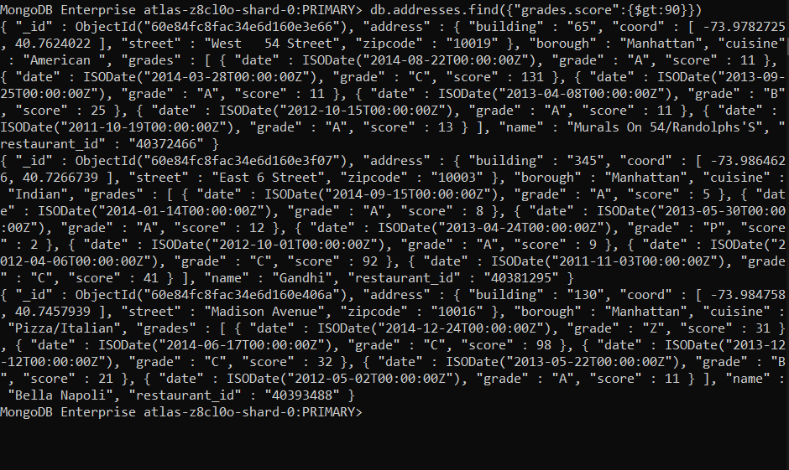

9] MongoDB Enterprise atlas-z8cl0o-shard-0:PRIMARY>

db.addresses.find({"grades.score":{$gt:90}})

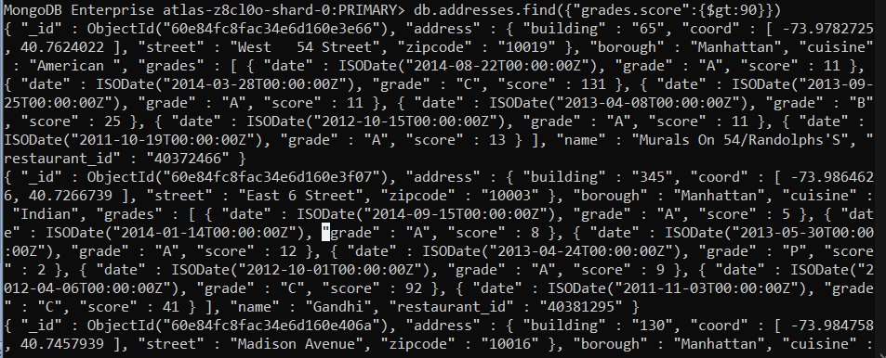

10] MongoDB Enterprise atlas-z8cl0o-shard-0:PRIMARY>

b.addresses.find({"address.coord" : {$lt : -95.754168}}

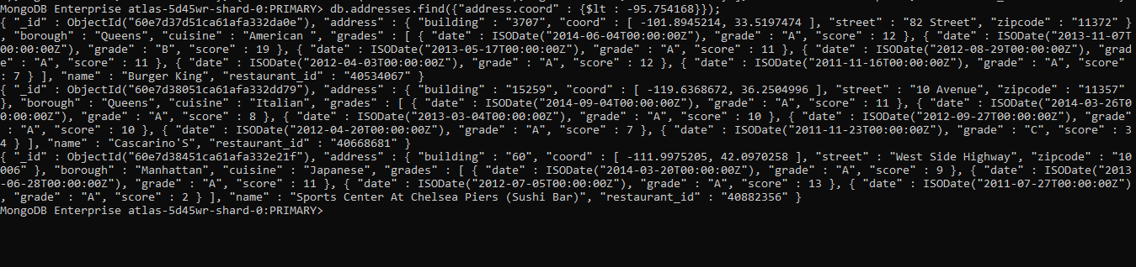

11 ] MongoDB Enterprise atlas-z8cl0o-shard-0:PRIMARY>

db.addresses.find(

... {$and:

... [

... {"cuisine" : {$ne :"American "}},

... {"grades.score" : {$gt : 70}},

... {"address.coord" : {$lt : -65.754168}}

... ]

... }

... );

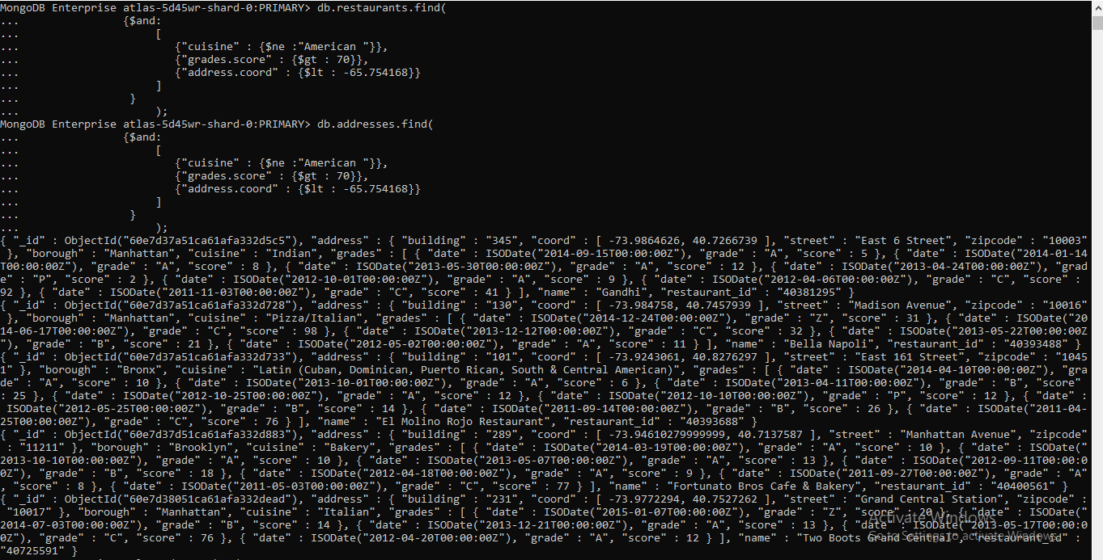

12] MongoDB Enterprise atlas-z8cl0o-shard-0:PRIMARY>

db.addresses.find(

... {$and:

... [

... {"cuisine" : {$ne :"American "}},

... {"grades.score" : {$gt : 70}},

... {"address.coord" : {$lt : -65.754168}}

... ]

... }

... )

13] MongoDB Enterprise atlas-z8cl0o-shard-0:PRIMARY>

db.addresses.find( {

... "cuisine" : {$ne : "American "},

... "grades.grade" :"A",

... "borough": {$ne : "Brooklyn"}

... }

... ).sort({"cuisine":-1});

{ "_id" : ObjectId("60e7d37d51ca61afa332dad2"), "address" : { "building" : "89", "coord" : [ -73.9995899, 40.7168015 ], "street" : "Baxter Street", "zipcode" : "10013" }, "borough" : "Manhattan", "cuisine" : "Vietnamese/Cambodian/Malaysia", "grades" : [ { "date" : ISODate("2014-08-21T00:00:00Z"), "grade" : "A", "score" : 13 }, { "date" : ISODate("2013-08-31T00:00:00Z"), "grade" : "A", "score" : 13 }, { "date" : ISODate("2013-04-11T00:00:00Z"), "grade" : "C", "score" : 3 }, { "date" : ISODate("2012-10-17T00:00:00Z"), "grade" : "A", "score" : 4 }, { "date" : ISODate("2012-05-15T00:00:00Z"), "grade" : "A", "score" : 10 } ], "name" : "Thai Son", "restaurant_id" : "40559606" }

{ "_id" : ObjectId("60e7d37d51ca61afa332db8b"), "address" : { "building" : "8278", "coord" : [ -73.88143509999999, 40.7412552 ], "street" : "Broadway", "zipcode" : "11373" }, "borough" : "Queens", "cuisine" : "Vietnamese/Cambodian/Malaysia", "grades" : [ { "date" : ISODate("2014-06-12T00:00:00Z"), "grade" : "B", "score" : 21 }, { "date" : ISODate("2013-05-20T00:00:00Z"), "grade" : "A", "score" : 13 }, { "date" : ISODate("2012-12-26T00:00:00Z"), "grade" : "A", "score" : 10 }, { "date" : ISODate("2012-12-03T00:00:00Z"), "grade" : "P", "score" : 5 }, { "date" : ISODate("2012-05-04T00:00:00Z"), "grade" : "B", "score" : 27 } ], "name" : "Pho Bac Vietnamese Seafood Cuisine", "restaurant_id" : "40578058" }

{ "_id" : ObjectId("60e7d38051ca61afa332df74"), "address" : { "building" : "148", "coord" : [ -74.000254, 40.7172727 ], "street" : "Centre Street", "zipcode" : "10013" }, "borough" : "Manhattan", "cuisine" : "Vietnamese/Cambodian/Malaysia", "grades" : [ { "date" : ISODate("2014-10-01T00:00:00Z"), "grade" : "A", "score" : 7 }, { "date" : ISODate("2014-05-19T00:00:00Z"), "grade" : "C", "score" : 5 }, { "date" : ISODate("2013-11-15T00:00:00Z"), "grade" : "B", "score" : 14 }, { "date" : ISODate("2013-03-08T00:00:00Z"), "grade" : "B", "score" : 25 }, { "date" : ISODate("2012-05-22T00:00:00Z"), "grade" : "B", "score" : 23 }, { "date" : ISODate("2011-10-27T00:00:00Z"), "grade" : "A", "score" : 9 } ], "name" : "Nha-Trang Centre Vietnam Restaurant", "restaurant_id" : "40751226" }

{ "_id" : ObjectId("60e7d37a51ca61afa332d676"), "address" : { "building" : "300", "coord" : [ -73.985568, 40.7307496 ], "street" : "East 12 Street", "zipcode" : "10003" }, "borough" : "Manhattan", "cuisine" : "Vegetarian", "grades" : [ { "date" : ISODate("2014-02-05T00:00:00Z"), "grade" : "A", "score" : 13 }, { "date" : ISODate("2013-04-24T00:00:00Z"), "grade" : "B", "score" : 19 }, { "date" : ISODate("2012-01-17T00:00:00Z"), "grade" : "A", "score" : 12 }, { "date" : ISODate("2011-07-25T00:00:00Z"), "grade" : "A", "score" : 10 } ], "name" : "Angelica Kitchen", "restaurant_id" : "40388281" }

{ "_id" : ObjectId("60e7d37d51ca61afa332d82b"), "address" : { "building" : "1307", "coord" : [ -73.9589834, 40.77141839999999 ], "street" : "3 Avenue", "zipcode" : "10021" }, "borough" : "Manhattan", "cuisine" : "Vegetarian", "grades" : [ { "date" : ISODate("2014-12-03T00:00:00Z"), "grade" : "A", "score" : 9 }, { "date" : ISODate("2014-02-18T00:00:00Z"), "grade" : "B", "score" : 22 }, { "date" : ISODate("2013-06-25T00:00:00Z"), "grade" : "A", "score" : 12 }, { "date" : ISODate("2012-06-28T00:00:00Z"), "grade" : "A", "score" : 12 } ], "name" : "Candle Cafe", "restaurant_id" : "40399007" }

{ "_id" : ObjectId("60e7d37d51ca61afa332d993"), "address" : { "building" : "547", "coord" : [ -92.7292446, 41.7461746 ], "street" : "6 Avenue", "zipcode" : "10011" }, "borough" : "Manhattan", "cuisine" : "Vegetarian", "grades" : [ { "date" : ISODate("2014-09-26T00:00:00Z"), "grade" : "A", "score" : 12 }, { "date" : ISODate("2014-04-07T00:00:00Z"), "grade" : "A", "score" : 12 }, { "date" : ISODate("2013-10-03T00:00:00Z"), "grade" : "A", "score" : 13 }, { "date" : ISODate("2012-09-10T00:00:00Z"), "grade" : "A", "score" : 7 }, { "date" : ISODate("2012-04-30T00:00:00Z"), "grade" : "A", "score" : 13 }, { "date" : ISODate("2011-11-30T00:00:00Z"), "grade" : "A", "score" : 11 } ], "name" : "Village Yogurt", "restaurant_id" : "40512123" }

{ "_id" : ObjectId("60e7d37d51ca61afa332da33"), "address" : { "building" : "46", "coord" : [ -74.000252, 40.7356228 ], "street" : "Greenwich Avenue", "zipcode" : "10011" }, "borough" : "Manhattan", "cuisine" : "Vegetarian", "grades" : [ { "date" : ISODate("2014-07-01T00:00:00Z"), "grade" : "A", "score" : 9 }, { "date" : ISODate("2013-12-31T00:00:00Z"), "grade" : "A", "score" : 11 }, { "date" : ISODate("2013-05-24T00:00:00Z"), "grade" : "A", "score" : 11 }, { "date" : ISODate("2012-10-11T00:00:00Z"), "grade" : "A", "score" : 6 } ], "name" : "Village Natural", "restaurant_id" : "40536786" }

{ "_id" : ObjectId("60e7d38051ca61afa332dcd4"), "address" : { "building" : "405", "coord" : [ -73.98565239999999, 40.7263767 ], "street" : "East 6 Street", "zipcode" : "10009" }, "borough" : "Manhattan", "cuisine" : "Vegetarian", "grades" : [ { "date" : ISODate("2014-09-29T00:00:00Z"), "grade" : "A", "score" : 9 }, { "date" : ISODate("2014-01-27T00:00:00Z"), "grade" : "B", "score" : 18 }, { "date" : ISODate("2013-07-31T00:00:00Z"), "grade" : "A", "score" : 11 }, { "date" : ISODate("2013-02-26T00:00:00Z"), "grade" : "B", "score" : 18 }, { "date" : ISODate("2012-08-06T00:00:00Z"), "grade" : "A", "score" : 13 }, { "date" : ISODate("2012-01-19T00:00:00Z"), "grade" : "B", "score" : 22 } ], "name" : "Caravan Of Dreams", "restaurant_id" : "40635781" }

{ "_id" : ObjectId("60e7d38051ca61afa332dcfa"), "address" : { "building" : "646", "coord" : [ -73.97279, 40.791289 ], "street" : "Amsterdam Avenue", "zipcode" : "10025" }, "borough" : "Manhattan", "cuisine" : "Vegetarian", "grades" : [ { "date" : ISODate("2014-02-19T00:00:00Z"), "grade" : "A", "score" : 13 }, { "date" : ISODate("2012-11-29T00:00:00Z"), "grade" : "A", "score" : 12 }, { "date" : ISODate("2011-10-03T00:00:00Z"), "grade" : "A", "score" : 13 }, { "date" : ISODate("2011-04-11T00:00:00Z"), "grade" : "A", "score" : 7 } ], "name" : "Mana", "restaurant_id" : "40644922" }

{ "_id" : ObjectId("60e7d38451ca61afa332e182"), "address" : { "building" : "140", "coord" : [ -74.0004534, 40.7311503 ], "street" : "West 4 Street", "zipcode" : "10012" }, "borough" : "Manhattan", "cuisine" : "Vegetarian", "grades" : [ { "date" : ISODate("2014-06-30T00:00:00Z"), "grade" : "A", "score" : 8 }, { "date" : ISODate("2013-06-13T00:00:00Z"), "grade" : "A", "score" : 7 }, { "date" : ISODate("2013-01-28T00:00:00Z"), "grade" : "C", "score" : 54 }, { "date" : ISODate("2012-06-21T00:00:00Z"), "grade" : "A", "score" : 6 }, { "date" : ISODate("2012-01-25T00:00:00Z"), "grade" : "A", "score" : 9 } ], "name" : "Red Bamboo", "restaurant_id" : "40861201" }

{ "_id" : ObjectId("60e7d37a51ca61afa332d3e2"), "address" : { "building" : "60", "coord" : [ -74.0085357, 40.70620539999999 ], "street" : "Wall Street", "zipcode" : "10005" }, "borough" : "Manhattan", "cuisine" : "Turkish", "grades" : [ { "date" : ISODate("2014-09-26T00:00:00Z"), "grade" : "A", "score" : 9 }, { "date" : ISODate("2013-09-18T00:00:00Z"), "grade" : "A", "score" : 13 }, { "date" : ISODate("2012-09-21T00:00:00Z"), "grade" : "A", "score" : 9 }, { "date" : ISODate("2012-05-09T00:00:00Z"), "grade" : "A", "score" : 11 } ], "name" : "The Country Cafe", "restaurant_id" : "40362715" }

{ "_id" : ObjectId("60e7d37d51ca61afa332d83d"), "address" : { "building" : "386", "coord" : [ -73.981366, 40.741888 ], "street" : "3 Avenue", "zipcode" : "10016" }, "borough" : "Manhattan", "cuisine" : "Turkish", "grades" : [ { "date" : ISODate("2014-09-23T00:00:00Z"), "grade" : "A", "score" : 9 }, { "date" : ISODate("2013-10-01T00:00:00Z"), "grade" : "A", "score" : 9 }, { "date" : ISODate("2012-09-10T00:00:00Z"), "grade" : "A", "score" : 5 } ], "name" : "Turkish Kitchen", "restaurant_id" : "40399372" }

{ "_id" : ObjectId("60e7d37d51ca61afa332dacd"), "address" : { "building" : "1405", "coord" : [ -73.95796530000001, 40.7697258 ], "street" : "Second Avenue", "zipcode" : "10021" }, "borough" : "Manhattan", "cuisine" : "Turkish", "grades" : [ { "date" : ISODate("2014-10-23T00:00:00Z"), "grade" : "A", "score" : 12 }, { "date" : ISODate("2014-03-20T00:00:00Z"), "grade" : "A", "score" : 9 }, { "date" : ISODate("2013-08-28T00:00:00Z"), "grade" : "B", "score" : 21 }, { "date" : ISODate("2012-12-05T00:00:00Z"), "grade" : "A", "score" : 11 }, { "date" : ISODate("2011-10-27T00:00:00Z"), "grade" : "A", "score" : 7 } ], "name" : "Uskudar Restaurant", "restaurant_id" : "40559172" }

{ "_id" : ObjectId("60e7d37d51ca61afa332dad1"), "address" : { "building" : "64", "coord" : [ -73.9788293, 40.7765158 ], "street" : "West 71 Street", "zipcode" : "10023" }, "borough" : "Manhattan", "cuisine" : "Turkish", "grades" : [ { "date" : ISODate("2014-09-04T00:00:00Z"), "grade" : "A", "score" : 12 }, { "date" : ISODate("2014-02-07T00:00:00Z"), "grade" : "A", "score" : 10 }, { "date" : ISODate("2013-04-18T00:00:00Z"), "grade" : "A", "score" : 13 }, { "date" : ISODate("2012-07-25T00:00:00Z"), "grade" : "A", "score" : 12 }, { "date" : ISODate("2012-02-01T00:00:00Z"), "grade" : "A", "score" : 7 } ], "name" : "Pasha Turkish Restaurant", "restaurant_id" : "40559546" }

{ "_id" : ObjectId("60e7d38051ca61afa332dc66"), "address" : { "building" : "25505", "coord" : [ -73.734503, 40.772264 ], "street" : "Northern Boulevard", "zipcode" : "11362" }, "borough" : "Queens", "cuisine" : "Turkish", "grades" : [ { "date" : ISODate("2014-12-29T00:00:00Z"), "grade" : "A", "score" : 9 }, { "date" : ISODate("2014-04-24T00:00:00Z"), "grade" : "A", "score" : 3 }, { "date" : ISODate("2013-09-25T00:00:00Z"), "grade" : "B", "score" : 17 }, { "date" : ISODate("2013-02-20T00:00:00Z"), "grade" : "A", "score" : 11 } ], "name" : "Kebab House", "restaurant_id" : "40608102" }

{ "_id" : ObjectId("60e7d38051ca61afa332dd76"), "address" : { "building" : "631", "coord" : [ -73.991755, 40.760138 ], "street" : "9 Avenue", "zipcode" : "10036" }, "borough" : "Manhattan", "cuisine" : "Turkish", "grades" : [ { "date" : ISODate("2014-06-10T00:00:00Z"), "grade" : "A", "score" : 12 }, { "date" : ISODate("2013-12-30T00:00:00Z"), "grade" : "A", "score" : 12 }, { "date" : ISODate("2013-04-24T00:00:00Z"), "grade" : "A", "score" : 11 }, { "date" : ISODate("2012-09-18T00:00:00Z"), "grade" : "A", "score" : 13 }, { "date" : ISODate("2012-02-22T00:00:00Z"), "grade" : "B", "score" : 20 } ], "name" : "Turkish Cuisine", "restaurant_id" : "40668464" }

{ "_id" : ObjectId("60e7d38051ca61afa332df60"), "address" : { "building" : "2637", "coord" : [ -73.970573, 40.797339 ], "street" : "Broadway", "zipcode" : "10025" }, "borough" : "Manhattan", "cuisine" : "Turkish", "grades" : [ { "date" : ISODate("2014-06-27T00:00:00Z"), "grade" : "A", "score" : 12 }, { "date" : ISODate("2013-04-29T00:00:00Z"), "grade" : "A", "score" : 7 }, { "date" : ISODate("2012-04-19T00:00:00Z"), "grade" : "A", "score" : 13 }, { "date" : ISODate("2011-10-05T00:00:00Z"), "grade" : "B", "score" : 15 } ], "name" : "Turkuaz Turkish Cuisine", "restaurant_id" : "40749081" }

{ "_id" : ObjectId("60e7d38351ca61afa332e08d"), "address" : { "building" : "513", "coord" : [ -73.978636, 40.74148 ], "street" : "2 Avenue", "zipcode" : "10016" }, "borough" : "Manhattan", "cuisine" : "Turkish", "grades" : [ { "date" : ISODate("2014-10-22T00:00:00Z"), "grade" : "A", "score" : 9 }, { "date" : ISODate("2014-05-08T00:00:00Z"), "grade" : "A", "score" : 7 }, { "date" : ISODate("2013-11-19T00:00:00Z"), "grade" : "A", "score" : 11 }, { "date" : ISODate("2013-04-03T00:00:00Z"), "grade" : "B", "score" : 26 }, { "date" : ISODate("2012-02-21T00:00:00Z"), "grade" : "A", "score" : 4 } ], "name" : "Saharas Turkish Cuisine", "restaurant_id" : "40815015" }

{ "_id" : ObjectId("60e7d37a51ca61afa332d545"), "address" : { "building" : "244", "coord" : [ -73.9865289, 40.7606981 ], "street" : "West 48 Street", "zipcode" : "10036" }, "borough" : "Manhattan", "cuisine" : "Thai", "grades" : [ { "date" : ISODate("2014-08-13T00:00:00Z"), "grade" : "A", "score" : 10 }, { "date" : ISODate("2014-01-14T00:00:00Z"), "grade" : "B", "score" : 24 }, { "date" : ISODate("2013-07-25T00:00:00Z"), "grade" : "A", "score" : 12 }, { "date" : ISODate("2013-01-10T00:00:00Z"), "grade" : "C", "score" : 4 }, { "date" : ISODate("2012-06-18T00:00:00Z"), "grade" : "A", "score" : 11 }, { "date" : ISODate("2012-02-17T00:00:00Z"), "grade" : "P", "score" : 6 } ], "name" : "Pongsri Thai Restaurant", "restaurant_id" : "40374088" }

{ "_id" : ObjectId("60e7d37a51ca61afa332d70d"), "address" : { "building" : "396", "coord" : [ -73.9809909, 40.7422324 ], "street" : "Third Avenue", "zipcode" : "10016" }, "borough" : "Manhattan", "cuisine" : "Thai", "grades" : [ { "date" : ISODate("2014-10-30T00:00:00Z"), "grade" : "A", "score" : 13 }, { "date" : ISODate("2014-06-04T00:00:00Z"), "grade" : "A", "score" : 7 }, { "date" : ISODate("2013-03-08T00:00:00Z"), "grade" : "A", "score" : 13 }, { "date" : ISODate("2012-10-01T00:00:00Z"), "grade" : "A", "score" : 9 } ], "name" : "Jaiya Thai Oriental Restaurant", "restaurant_id" : "40392724" }

14] MongoDB Enterprise atlas-z8cl0o-shard-0:PRIMARY>

db.addresses.find(

... {name: /^Wil/},

... {

... "restaurant_id" : 1,

... "name":1,"borough":1,

... "cuisine" :1

... }

... );

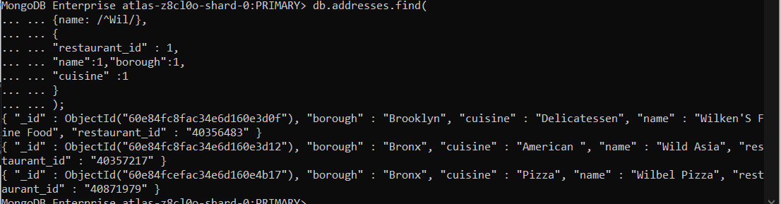

15] MongoDB Enterprise atlas-z8cl0o-shard-0:PRIMARY>

db.addresses.find(

... {name: /ces$/},

... {

... "restaurant_id" : 1,

... "name":1,"borough":1,

... "cuisine" :1

... }

... );

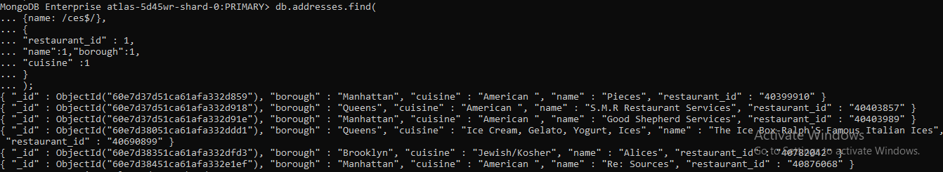

16] MongoDB Enterprise atlas-z8cl0o-shard-0:PRIMARY>

db.addresses.find(

... {"name": /.*Reg.*/},

... {

... "restaurant_id" : 1,

... "name":1,"borough":1,

... "cuisine" :1

... }

... );

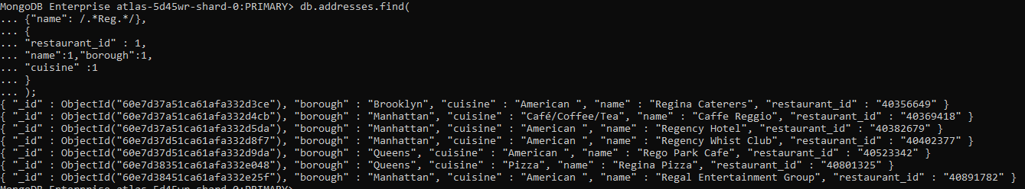

17] MongoDB Enterprise atlas-z8cl0o-shard-0:PRIMARY>

> db.addresses.find(

... {

... "borough": "Bronx" ,

... $or : [

... { "cuisine" : "American " },

... { "cuisine" : "Chinese" }

... ]

... }

... );

{ "_id" : ObjectId("60e7d37a51ca61afa332d3d0"), "address" : { "building" : "2300", "coord" : [ -73.8786113, 40.8502883 ], "street" : "Southern Boulevard", "zipcode" : "10460" }, "borough" : "Bronx", "cuisine" : "American ", "grades" : [ { "date" : ISODate("2014-05-28T00:00:00Z"), "grade" : "A", "score" : 11 }, { "date" : ISODate("2013-06-19T00:00:00Z"), "grade" : "A", "score" : 4 }, { "date" : ISODate("2012-06-15T00:00:00Z"), "grade" : "A", "score" : 3 } ], "name" : "Wild Asia", "restaurant_id" : "40357217" }

{ "_id" : ObjectId("60e7d37a51ca61afa332d3e9"), "address" : { "building" : "1236", "coord" : [ -73.8893654, 40.81376179999999 ], "street" : "238 Spofford Ave", "zipcode" : "10474" }, "borough" : "Bronx", "cuisine" : "Chinese", "grades" : [ { "date" : ISODate("2013-12-30T00:00:00Z"), "grade" : "A", "score" : 8 }, { "date" : ISODate("2013-01-08T00:00:00Z"), "grade" : "A", "score" : 10 }, { "date" : ISODate("2012-06-12T00:00:00Z"), "grade" : "B", "score" : 15 } ], "name" : "Happy Garden", "restaurant_id" : "40363289" }

{ "_id" : ObjectId("60e7d37a51ca61afa332d3fb"), "address" : { "building" : "277", "coord" : [ -73.8941893, 40.8634684 ], "street" : "East Kingsbridge Road", "zipcode" : "10458" }, "borough" : "Bronx", "cuisine" : "Chinese", "grades" : [ { "date" : ISODate("2014-03-03T00:00:00Z"), "grade" : "A", "score" : 10 }, { "date" : ISODate("2013-09-26T00:00:00Z"), "grade" : "A", "score" : 10 }, { "date" : ISODate("2013-03-19T00:00:00Z"), "grade" : "A", "score" : 10 }, { "date" : ISODate("2012-08-29T00:00:00Z"), "grade" : "A", "score" : 11 }, { "date" : ISODate("2011-08-17T00:00:00Z"), "grade" : "A", "score" : 13 } ], "name" : "Happy Garden", "restaurant_id" : "40364296" }

{ "_id" : ObjectId("60e7d37a51ca61afa332d403"), "address" : { "building" : "658", "coord" : [ -73.81363999999999, 40.82941100000001 ], "street" : "Clarence Ave", "zipcode" : "10465" }, "borough" : "Bronx", "cuisine" : "American ", "grades" : [ { "date" : ISODate("2014-06-21T00:00:00Z"), "grade" : "A", "score" : 5 }, { "date" : ISODate("2012-07-11T00:00:00Z"), "grade" : "A", "score" : 10 } ], "name" : "Manhem Club", "restaurant_id" : "40364363" }

{ "_id" : ObjectId("60e7d37a51ca61afa332d41b"), "address" : { "building" : "2222", "coord" : [ -73.84971759999999, 40.8304811 ], "street" : "Haviland Avenue", "zipcode" : "10462" }, "borough" : "Bronx", "cuisine" : "American ", "grades" : [ { "date" : ISODate("2014-12-18T00:00:00Z"), "grade" : "A", "score" : 7 }, { "date" : ISODate("2014-05-01T00:00:00Z"), "grade" : "B", "score" : 17 }, { "date" : ISODate("2013-03-14T00:00:00Z"), "grade" : "A", "score" : 12 }, { "date" : ISODate("2012-09-20T00:00:00Z"), "grade" : "A", "score" : 9 }, { "date" : ISODate("2012-02-08T00:00:00Z"), "grade" : "B", "score" : 19 } ], "name" : "The New Starling Athletic Club Of The Bronx", "restaurant_id" : "40364956" }

{ "_id" : ObjectId("60e7d37a51ca61afa332d433"), "address" : { "building" : "72", "coord" : [ -73.92506, 40.8275556 ], "street" : "East 161 Street", "zipcode" : "10451" }, "borough" : "Bronx", "cuisine" : "American ", "grades" : [ { "date" : ISODate("2014-04-15T00:00:00Z"), "grade" : "A", "score" : 9 }, { "date" : ISODate("2013-11-14T00:00:00Z"), "grade" : "A", "score" : 4 }, { "date" : ISODate("2013-07-29T00:00:00Z"), "grade" : "A", "score" : 10 }, { "date" : ISODate("2012-12-31T00:00:00Z"), "grade" : "B", "score" : 15 }, { "date" : ISODate("2012-05-30T00:00:00Z"), "grade" : "A", "score" : 13 }, { "date" : ISODate("2012-01-09T00:00:00Z"), "grade" : "A", "score" : 10 }, { "date" : ISODate("2011-08-15T00:00:00Z"), "grade" : "C", "score" : 37 } ], "name" : "Yankee Tavern", "restaurant_id" : "40365499" }

{ "_id" : ObjectId("60e7d37a51ca61afa332d45f"), "address" : { "building" : "5820", "coord" : [ -73.9002615, 40.885186 ], "street" : "Broadway", "zipcode" : "10463" }, "borough" : "Bronx", "cuisine" : "American ", "grades" : [ { "date" : ISODate("2014-02-26T00:00:00Z"), "grade" : "A", "score" : 5 }, { "date" : ISODate("2013-10-09T00:00:00Z"), "grade" : "B", "score" : 19 }, { "date" : ISODate("2013-05-15T00:00:00Z"), "grade" : "A", "score" : 9 }, { "date" : ISODate("2012-11-20T00:00:00Z"), "grade" : "B", "score" : 18 }, { "date" : ISODate("2011-10-17T00:00:00Z"), "grade" : "A", "score" : 10 }, { "date" : ISODate("2011-06-22T00:00:00Z"), "grade" : "C", "score" : 35 } ], "name" : "The Punch Bowl", "restaurant_id" : "40366497" }

{ "_id" : ObjectId("60e7d37a51ca61afa332d46a"), "address" : { "building" : "21", "coord" : [ -73.9168424, 40.8401362 ], "street" : "East 170 Street", "zipcode" : "10452" }, "borough" : "Bronx", "cuisine" : "American ", "grades" : [ { "date" : ISODate("2014-12-16T00:00:00Z"), "grade" : "B", "score" : 22 }, { "date" : ISODate("2014-08-12T00:00:00Z"), "grade" : "A", "score" : 7 }, { "date" : ISODate("2014-03-03T00:00:00Z"), "grade" : "B", "score" : 22 }, { "date" : ISODate("2013-08-29T00:00:00Z"), "grade" : "A", "score" : 12 }, { "date" : ISODate("2012-08-29T00:00:00Z"), "grade" : "A", "score" : 10 }, { "date" : ISODate("2012-02-13T00:00:00Z"), "grade" : "B", "score" : 16 } ], "name" : "Munchtime", "restaurant_id" : "40366748" }

{ "_id" : ObjectId("60e7d37a51ca61afa332d477"), "address" : { "building" : "2894", "coord" : [ -73.815175, 40.8137649 ], "street" : "Schurz Ave", "zipcode" : "10465" }, "borough" : "Bronx", "cuisine" : "American ", "grades" : [ { "date" : ISODate("2014-10-31T00:00:00Z"), "grade" : "B", "score" : 18 }, { "date" : ISODate("2014-02-20T00:00:00Z"), "grade" : "A", "score" : 4 }, { "date" : ISODate("2013-06-07T00:00:00Z"), "grade" : "A", "score" : 12 }, { "date" : ISODate("2012-05-17T00:00:00Z"), "grade" : "A", "score" : 2 } ], "name" : "Marina Delray", "restaurant_id" : "40367161" }

{ "_id" : ObjectId("60e7d37a51ca61afa332d49f"), "address" : { "building" : "2300", "coord" : [ -73.8786113, 40.8502883 ], "street" : "Southern Boulevard", "zipcode" : "10460" }, "borough" : "Bronx", "cuisine" : "American ", "grades" : [ { "date" : ISODate("2014-05-21T00:00:00Z"), "grade" : "A", "score" : 2 }, { "date" : ISODate("2013-05-22T00:00:00Z"), "grade" : "A", "score" : 11 }, { "date" : ISODate("2012-05-17T00:00:00Z"), "grade" : "A", "score" : 12 }, { "date" : ISODate("2011-06-08T00:00:00Z"), "grade" : "A", "score" : 5 } ], "name" : "Cool Zone", "restaurant_id" : "40368022" }

{ "_id" : ObjectId("60e7d37a51ca61afa332d4a0"), "address" : { "building" : "2300", "coord" : [ -73.8786113, 40.8502883 ], "street" : "Southern Boulevard", "zipcode" : "10460" }, "borough" : "Bronx", "cuisine" : "American ", "grades" : [ { "date" : ISODate("2014-05-21T00:00:00Z"), "grade" : "A", "score" : 11 }, { "date" : ISODate("2013-05-29T00:00:00Z"), "grade" : "A", "score" : 10 }, { "date" : ISODate("2012-06-15T00:00:00Z"), "grade" : "A", "score" : 2 }, { "date" : ISODate("2011-06-08T00:00:00Z"), "grade" : "A", "score" : 0 } ], "name" : "Beaver Pond", "restaurant_id" : "40368025" }

{ "_id" : ObjectId("60e7d37a51ca61afa332d4a1"), "address" : { "building" : "2300", "coord" : [ -73.8786113, 40.8502883 ], "street" : "Southern Boulevard", "zipcode" : "10460" }, "borough" : "Bronx", "cuisine" : "American ", "grades" : [ { "date" : ISODate("2014-05-21T00:00:00Z"), "grade" : "A", "score" : 5 }, { "date" : ISODate("2013-05-28T00:00:00Z"), "grade" : "A", "score" : 3 }, { "date" : ISODate("2012-06-18T00:00:00Z"), "grade" : "A", "score" : 4 }, { "date" : ISODate("2011-06-07T00:00:00Z"), "grade" : "A", "score" : 9 } ], "name" : "African Market (Baboon Cafe)", "restaurant_id" : "40368026" }

{ "_id" : ObjectId("60e7d37a51ca61afa332d4c1"), "address" : { "building" : "3533", "coord" : [ -73.9100082, 40.8863835 ], "street" : "Johnson Avenue", "zipcode" : "10463" }, "borough" : "Bronx", "cuisine" : "American ", "grades" : [ { "date" : ISODate("2014-02-20T00:00:00Z"), "grade" : "A", "score" : 12 }, { "date" : ISODate("2013-09-09T00:00:00Z"), "grade" : "A", "score" : 12 }, { "date" : ISODate("2013-03-26T00:00:00Z"), "grade" : "A", "score" : 5 }, { "date" : ISODate("2013-03-08T00:00:00Z"), "grade" : "P", "score" : 2 }, { "date" : ISODate("2012-09-26T00:00:00Z"), "grade" : "A", "score" : 9 }, { "date" : ISODate("2012-04-13T00:00:00Z"), "grade" : "A", "score" : 11 }, { "date" : ISODate("2011-07-26T00:00:00Z"), "grade" : "A", "score" : 13 }, { "date" : ISODate("2011-02-26T00:00:00Z"), "grade" : "A", "score" : 13 } ], "name" : "Blue Bay Restaurant", "restaurant_id" : "40369087" }

{ "_id" : ObjectId("60e7d37a51ca61afa332d4d3"), "address" : { "building" : "2375", "coord" : [ -73.85534559999999, 40.8426433 ], "street" : "East Tremont Avenue", "zipcode" : "10462" }, "borough" : "Bronx", "cuisine" : "American ", "grades" : [ { "date" : ISODate("2014-10-14T00:00:00Z"), "grade" : "A", "score" : 13 }, { "date" : ISODate("2014-04-08T00:00:00Z"), "grade" : "A", "score" : 8 }, { "date" : ISODate("2013-11-04T00:00:00Z"), "grade" : "C", "score" : 45 }, { "date" : ISODate("2013-05-23T00:00:00Z"), "grade" : "A", "score" : 10 }, { "date" : ISODate("2012-10-18T00:00:00Z"), "grade" : "B", "score" : 15 }, { "date" : ISODate("2012-10-05T00:00:00Z"), "grade" : "P", "score" : 12 }, { "date" : ISODate("2012-05-14T00:00:00Z"), "grade" : "A", "score" : 12 }, { "date" : ISODate("2011-12-21T00:00:00Z"), "grade" : "A", "score" : 11 } ], "name" : "Bronx Grill", "restaurant_id" : "40369601" }

{ "_id" : ObjectId("60e7d37a51ca61afa332d4e5"), "address" : { "building" : "170", "coord" : [ -73.9035553, 40.878342 ], "street" : "West 231 Street", "zipcode" : "10463" }, "borough" : "Bronx", "cuisine" : "American ", "grades" : [ { "date" : ISODate("2014-10-01T00:00:00Z"), "grade" : "B", "score" : 18 }, { "date" : ISODate("2014-04-23T00:00:00Z"), "grade" : "A", "score" : 12 }, { "date" : ISODate("2013-10-23T00:00:00Z"), "grade" : "A", "score" : 11 }, { "date" : ISODate("2013-05-21T00:00:00Z"), "grade" : "B", "score" : 19 }, { "date" : ISODate("2013-05-02T00:00:00Z"), "grade" : "P", "score" : 3 }, { "date" : ISODate("2012-11-20T00:00:00Z"), "grade" : "B", "score" : 24 } ], "name" : "P & K'S Grill", "restaurant_id" : "40369895" }

{ "_id" : ObjectId("60e7d37a51ca61afa332d4ef"), "address" : { "building" : "4272", "coord" : [ -73.86720489999999, 40.8977501 ], "street" : "Katonah Avenue", "zipcode" : "10470" }, "borough" : "Bronx", "cuisine" : "American ", "grades" : [ { "date" : ISODate("2014-05-23T00:00:00Z"), "grade" : "A", "score" : 11 }, { "date" : ISODate("2013-11-04T00:00:00Z"), "grade" : "A", "score" : 10 }, { "date" : ISODate("2013-04-29T00:00:00Z"), "grade" : "A", "score" : 10 }, { "date" : ISODate("2012-09-24T00:00:00Z"), "grade" : "B", "score" : 15 } ], "name" : "John Mulligan'S Fireside Pub", "restaurant_id" : "40370150" }

{ "_id" : ObjectId("60e7d37a51ca61afa332d549"), "address" : { "building" : "2942", "coord" : [ -73.832183, 40.84710099999999 ], "street" : "Westchester Avenue", "zipcode" : "10461" }, "borough" : "Bronx", "cuisine" : "American ", "grades" : [ { "date" : ISODate("2014-02-10T00:00:00Z"), "grade" : "A", "score" : 8 }, { "date" : ISODate("2013-09-18T00:00:00Z"), "grade" : "A", "score" : 12 }, { "date" : ISODate("2013-04-17T00:00:00Z"), "grade" : "B", "score" : 25 }, { "date" : ISODate("2012-10-15T00:00:00Z"), "grade" : "B", "score" : 25 }, { "date" : ISODate("2011-10-17T00:00:00Z"), "grade" : "A", "score" : 12 }, { "date" : ISODate("2011-07-14T00:00:00Z"), "grade" : "B", "score" : 18 } ], "name" : "Quality Cafe & Restaurant", "restaurant_id" : "40374259" }

{ "_id" : ObjectId("60e7d37a51ca61afa332d5b3"), "address" : { "building" : "3657", "coord" : [ -73.901496, 40.885102 ], "street" : "Kingsbridge Avenue", "zipcode" : "10463" }, "borough" : "Bronx", "cuisine" : "American ", "grades" : [ { "date" : ISODate("2014-09-25T00:00:00Z"), "grade" : "A", "score" : 10 }, { "date" : ISODate("2014-04-30T00:00:00Z"), "grade" : "B", "score" : 20 }, { "date" : ISODate("2013-08-19T00:00:00Z"), "grade" : "A", "score" : 2 }, { "date" : ISODate("2013-03-06T00:00:00Z"), "grade" : "A", "score" : 13 }, { "date" : ISODate("2012-01-26T00:00:00Z"), "grade" : "A", "score" : 9 }, { "date" : ISODate("2011-10-19T00:00:00Z"), "grade" : "B", "score" : 18 } ], "name" : "Riverdale Diner", "restaurant_id" : "40380253" }

{ "_id" : ObjectId("60e7d37a51ca61afa332d5d8"), "address" : { "building" : "1506", "coord" : [ -73.8537226, 40.8427071 ], "street" : "Bronxdale Avenue", "zipcode" : "10462" }, "borough" : "Bronx", "cuisine" : "American ", "grades" : [ { "date" : ISODate("2014-06-04T00:00:00Z"), "grade" : "A", "score" : 5 }, { "date" : ISODate("2013-05-22T00:00:00Z"), "grade" : "A", "score" : 10 }, { "date" : ISODate("2012-12-13T00:00:00Z"), "grade" : "A", "score" : 12 }, { "date" : ISODate("2012-05-14T00:00:00Z"), "grade" : "B", "score" : 16 }, { "date" : ISODate("2011-12-28T00:00:00Z"), "grade" : "A", "score" : 13 }, { "date" : ISODate("2011-08-10T00:00:00Z"), "grade" : "A", "score" : 11 } ], "name" : "Castlehill Diner", "restaurant_id" : "40382517" }

{ "_id" : ObjectId("60e7d37a51ca61afa332d5f4"), "address" : { "building" : "5977", "coord" : [ -73.8982704, 40.8896923 ], "street" : "Broadway", "zipcode" : "10463" }, "borough" : "Bronx", "cuisine" : "American ", "grades" : [ { "date" : ISODate("2014-05-30T00:00:00Z"), "grade" : "A", "score" : 6 }, { "date" : ISODate("2013-04-25T00:00:00Z"), "grade" : "A", "score" : 7 }, { "date" : ISODate("2012-11-20T00:00:00Z"), "grade" : "A", "score" : 12 }, { "date" : ISODate("2012-05-30T00:00:00Z"), "grade" : "A", "score" : 10 }, { "date" : ISODate("2011-12-19T00:00:00Z"), "grade" : "B", "score" : 18 } ], "name" : "Short Stop Restaurant", "restaurant_id" : "40383819" }

18] MongoDB Enterprise atlas-z8cl0o-shard-0:PRIMARY>

db.addresses.find(

... {$or :[ {"borough" :"Staten Island"},{"borough" :"Queens"},{"borough": "Bronx"},{"borough" :"Brooklyn"}]},

... {

... "restaurant_id" : 1,

... "name":1,"borough":1,

... "cuisine" :1

... }

... );

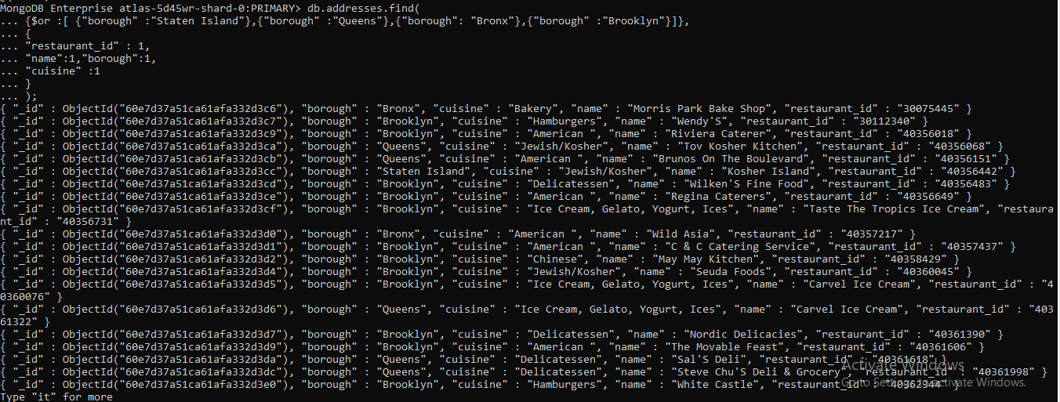

19] MongoDB Enterprise atlas-z8cl0o-shard-0:PRIMARY>

db.addresses.find(

... {"borough" :{$nin :["Staten Island","Queens","Bronx","Brooklyn"]}},

... {

... "restaurant_id" : 1,

... "name":1,"borough":1,

... "cuisine" :1

... }

... );

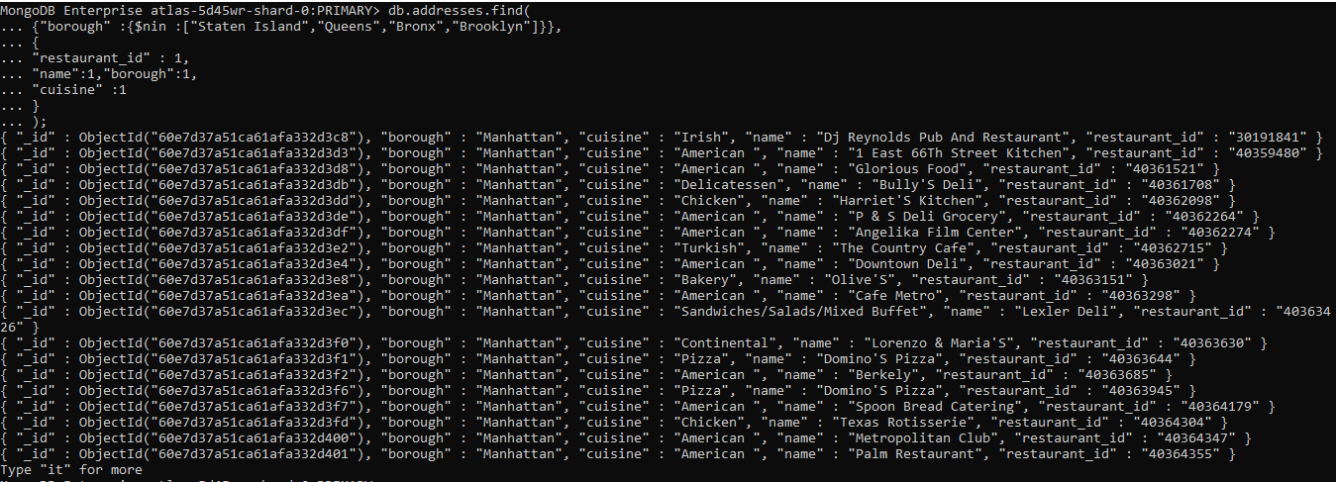

20] MongoDB Enterprise atlas-z8cl0o-shard-0:PRIMARY>

db.addresses.find(

... {"grades.score" :

... { $not:

... {$gt : 10}

... }

... },

... {

... "restaurant_id" : 1,

... "name":1,"borough":1,

... "cuisine" :1

... }

... );

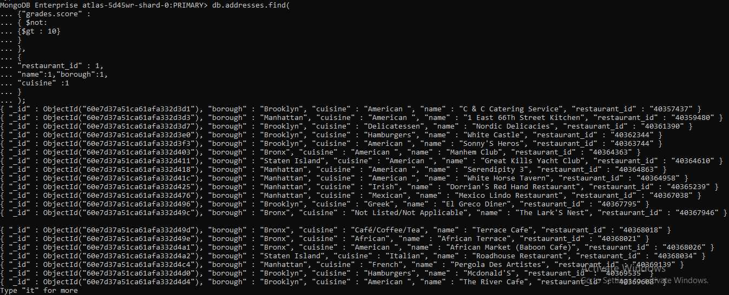

22] MongoDB Enterprise atlas-z8cl0o-shard-0:PRIMARY>

db.addresses.find(

... {

... "grades.date": ISODate("2014-08-11T00:00:00Z"),

... "grades.grade":"A" ,

... "grades.score" : 11

... },

... {"restaurant_id" : 1,"name":1,"grades":1}

... );

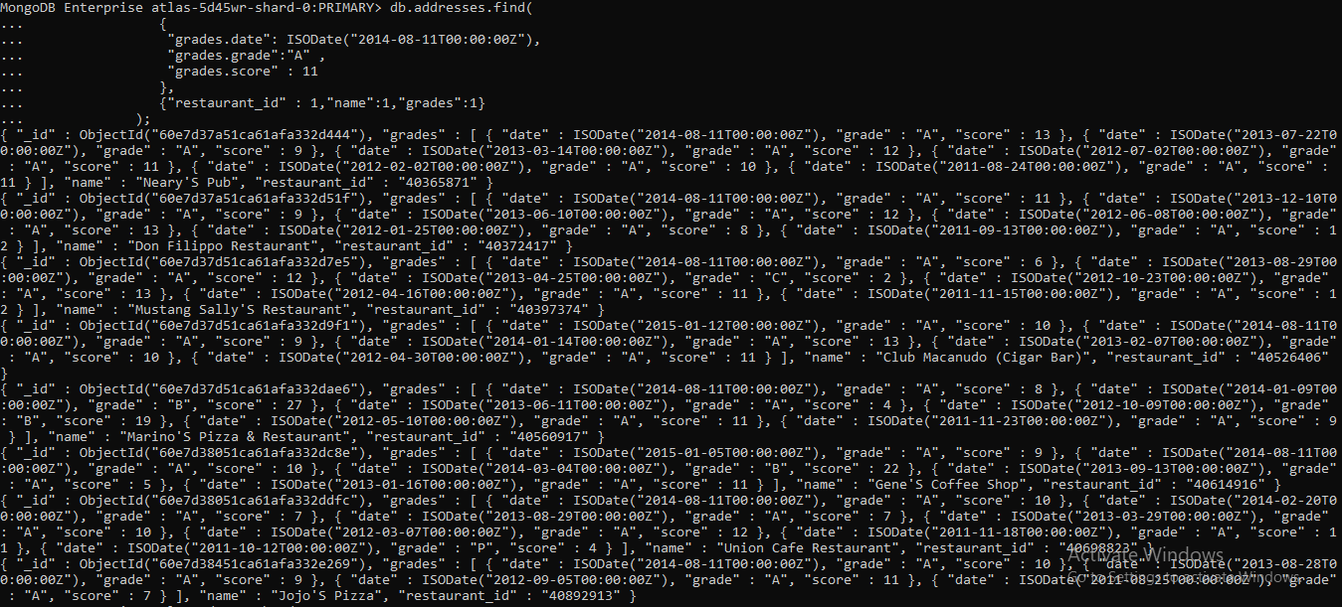

23] MongoDB Enterprise atlas-z8cl0o-shard-0:PRIMARY>

db.addresses.find(

... { "grades.1.date": ISODate("2014-08-11T00:00:00Z"),

... "grades.1.grade":"A" ,

... "grades.1.score" : 9

... },

... {"restaurant_id" : 1,"name":1,"grades":1}

... );

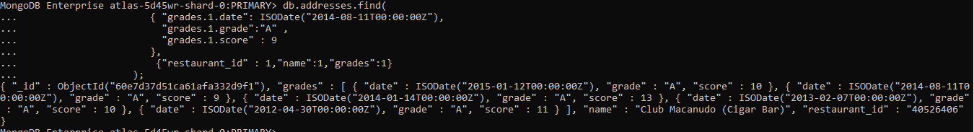

24] MongoDB Enterprise atlas-z8cl0o-shard-0:PRIMARY>

db.addresses.find(

... {

... "address.coord.1": {$gt : 42, $lte : 52}

... },

... {"restaurant_id" : 1,"name":1,"address":1,"coord":1}

... );

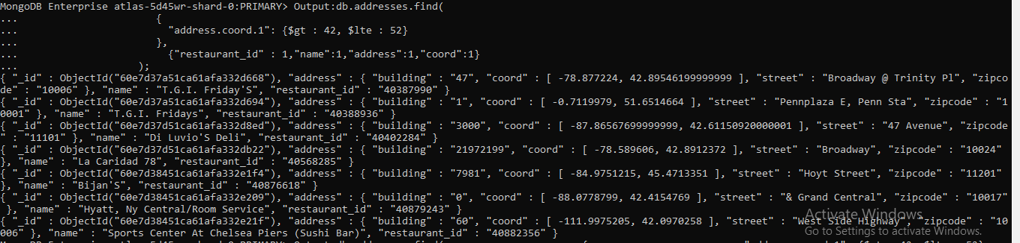

25] MongoDB Enterprise atlas-z8cl0o-shard-0:PRIMARY>

db.addresses.find().sort({"name":1});

{ "_id" : ObjectId("60e7d38351ca61afa332e056"), "address" : { "building" : "129", "coord" : [ -73.962943, 40.685007 ], "street" : "Gates Avenue", "zipcode" : "11238" }, "borough" : "Brooklyn", "cuisine" : "Italian", "grades" : [ { "date" : ISODate("2014-03-06T00:00:00Z"), "grade" : "A", "score" : 5 }, { "date" : ISODate("2013-08-29T00:00:00Z"), "grade" : "A", "score" : 2 }, { "date" : ISODate("2013-03-08T00:00:00Z"), "grade" : "A", "score" : 7 }, { "date" : ISODate("2012-06-27T00:00:00Z"), "grade" : "A", "score" : 7 }, { "date" : ISODate("2011-11-17T00:00:00Z"), "grade" : "A", "score" : 12 } ], "name" : "(Lewis Drug Store) Locanda Vini E Olii", "restaurant_id" : "40804423" }

{ "_id" : ObjectId("60e7d37a51ca61afa332d3d3"), "address" : { "building" : "1", "coord" : [ -73.96926909999999, 40.7685235 ], "street" : "East 66 Street", "zipcode" : "10065" }, "borough" : "Manhattan", "cuisine" : "American ", "grades" : [ { "date" : ISODate("2014-05-07T00:00:00Z"), "grade" : "A", "score" : 3 }, { "date" : ISODate("2013-05-03T00:00:00Z"), "grade" : "A", "score" : 4 }, { "date" : ISODate("2012-04-30T00:00:00Z"), "grade" : "A", "score" : 6 }, { "date" : ISODate("2011-12-27T00:00:00Z"), "grade" : "A", "score" : 0 } ], "name" : "1 East 66Th Street Kitchen", "restaurant_id" : "40359480" }

{ "_id" : ObjectId("60e7d38051ca61afa332dbe5"), "address" : { "building" : "10016", "coord" : [ -73.8216636, 40.5838155 ], "street" : "Rockaway Beach Boulevard", "zipcode" : "11694" }, "borough" : "Queens", "cuisine" : "Delicatessen", "grades" : [ { "date" : ISODate("2014-01-28T00:00:00Z"), "grade" : "A", "score" : 11 }, { "date" : ISODate("2013-08-20T00:00:00Z"), "grade" : "A", "score" : 9 }, { "date" : ISODate("2013-03-19T00:00:00Z"), "grade" : "A", "score" : 10 }, { "date" : ISODate("2012-03-06T00:00:00Z"), "grade" : "A", "score" : 10 }, { "date" : ISODate("2011-03-01T00:00:00Z"), "grade" : "A", "score" : 12 } ], "name" : "101 Deli", "restaurant_id" : "40591271" }

{ "_id" : ObjectId("60e7d37d51ca61afa332dad9"), "address" : { "building" : "10018", "coord" : [ -74.0343092, 40.6125569 ], "street" : "4 Avenue", "zipcode" : "11209" }, "borough" : "Brooklyn", "cuisine" : "Italian", "grades" : [ { "date" : ISODate("2014-12-01T00:00:00Z"), "grade" : "A", "score" : 5 }, { "date" : ISODate("2013-11-29T00:00:00Z"), "grade" : "A", "score" : 13 }, { "date" : ISODate("2013-06-03T00:00:00Z"), "grade" : "A", "score" : 10 }, { "date" : ISODate("2012-06-05T00:00:00Z"), "grade" : "B", "score" : 15 }, { "date" : ISODate("2012-01-10T00:00:00Z"), "grade" : "A", "score" : 10 } ], "name" : "101 Restaurant And Bar", "restaurant_id" : "40560108" }

{ "_id" : ObjectId("60e7d37d51ca61afa332d8a6"), "address" : { "building" : "1020", "coord" : [ -73.96396419999999, 40.8032642 ], "street" : "Amsterdam Avenue", "zipcode" : "10025" }, "borough" : "Manhattan", "cuisine" : "American ", "grades" : [ { "date" : ISODate("2014-06-26T00:00:00Z"), "grade" : "A", "score" : 10 }, { "date" : ISODate("2013-06-19T00:00:00Z"), "grade" : "A", "score" : 7 }, { "date" : ISODate("2012-12-27T00:00:00Z"), "grade" : "C", "score" : 38 } ], "name" : "1020 Bar", "restaurant_id" : "40401104" }

{ "_id" : ObjectId("60e7d38051ca61afa332dce0"), "address" : { "building" : "10401", "coord" : [ -73.9004264, 40.6520939 ], "street" : "Foster Avenue", "zipcode" : "11236" }, "borough" : "Brooklyn", "cuisine" : "Café/Coffee/Tea", "grades" : [ { "date" : ISODate("2014-12-08T00:00:00Z"), "grade" : "A", "score" : 13 }, { "date" : ISODate("2014-04-08T00:00:00Z"), "grade" : "B", "score" : 19 }, { "date" : ISODate("2013-03-07T00:00:00Z"), "grade" : "A", "score" : 12 }, { "date" : ISODate("2012-10-04T00:00:00Z"), "grade" : "A", "score" : 8 } ], "name" : "104-01 Foster Avenue Coffee Shop(Ups)", "restaurant_id" : "40639261" }

{ "_id" : ObjectId("60e7d38051ca61afa332dd8c"), "address" : { "building" : "256", "coord" : [ -73.998993, 40.74718060000001 ], "street" : "10Th Ave Bet 24 & 25 St )", "zipcode" : "10001" }, "borough" : "Manhattan", "cuisine" : "Pizza", "grades" : [ { "date" : ISODate("2014-11-10T00:00:00Z"), "grade" : "A", "score" : 10 }, { "date" : ISODate("2013-10-21T00:00:00Z"), "grade" : "A", "score" : 9 }, { "date" : ISODate("2013-05-31T00:00:00Z"), "grade" : "A", "score" : 12 }, { "date" : ISODate("2012-12-14T00:00:00Z"), "grade" : "A", "score" : 7 }, { "date" : ISODate("2012-07-09T00:00:00Z"), "grade" : "A", "score" : 10 }, { "date" : ISODate("2012-02-03T00:00:00Z"), "grade" : "A", "score" : 9 } ], "name" : "10Th Avenue Pizza & Cafe", "restaurant_id" : "40673117" }

{ "_id" : ObjectId("60e7d38451ca61afa332e22e"), "address" : { "building" : "0", "coord" : [ -73.7889689, 40.6433507 ], "street" : "Central Taxi Hold", "zipcode" : "11430" }, "borough" : "Queens", "cuisine" : "American ", "grades" : [ { "date" : ISODate("2014-03-06T00:00:00Z"), "grade" : "A", "score" : 9 }, { "date" : ISODate("2013-09-18T00:00:00Z"), "grade" : "A", "score" : 12 }, { "date" : ISODate("2012-08-21T00:00:00Z"), "grade" : "A", "score" : 3 }, { "date" : ISODate("2012-02-06T00:00:00Z"), "grade" : "B", "score" : 15 } ], "name" : "111 Restaurant", "restaurant_id" : "40884354" }

{ "_id" : ObjectId("60e7d38051ca61afa332ddfe"), "address" : { "building" : "15", "coord" : [ -73.9921155, 40.7364657 ], "street" : "East 15 Street", "zipcode" : "10003" }, "borough" : "Manhattan", "cuisine" : "Japanese", "grades" : [ { "date" : ISODate("2014-06-28T00:00:00Z"), "grade" : "A", "score" : 10 }, { "date" : ISODate("2013-10-22T00:00:00Z"), "grade" : "A", "score" : 13 }, { "date" : ISODate("2013-03-22T00:00:00Z"), "grade" : "C", "score" : 64 }, { "date" : ISODate("2012-07-05T00:00:00Z"), "grade" : "A", "score" : 11 }, { "date" : ISODate("2012-02-03T00:00:00Z"), "grade" : "A", "score" : 11 }, { "date" : ISODate("2011-06-30T00:00:00Z"), "grade" : "A", "score" : 10 } ], "name" : "15 East Restaurant", "restaurant_id" : "40698892" }

{ "_id" : ObjectId("60e7d37a51ca61afa332d619"), "address" : { "building" : "200", "coord" : [ -73.9804898, 40.6768216 ], "street" : "5 Avenue", "zipcode" : "11217" }, "borough" : "Brooklyn", "cuisine" : "American ", "grades" : [ { "date" : ISODate("2014-07-03T00:00:00Z"), "grade" : "B", "score" : 26 }, { "date" : ISODate("2013-10-30T00:00:00Z"), "grade" : "A", "score" : 12 }, { "date" : ISODate("2013-03-21T00:00:00Z"), "grade" : "A", "score" : 13 }, { "date" : ISODate("2012-08-07T00:00:00Z"), "grade" : "A", "score" : 13 }, { "date" : ISODate("2012-03-09T00:00:00Z"), "grade" : "C", "score" : 42 }, { "date" : ISODate("2011-10-13T00:00:00Z"), "grade" : "A", "score" : 13 } ], "name" : "200 Fifth Avenue Restaurant & Sports Bar", "restaurant_id" : "40385555" }

{ "_id" : ObjectId("60e7d37a51ca61afa332d402"), "address" : { "building" : "21", "coord" : [ -73.9774394, 40.7604522 ], "street" : "West 52 Street", "zipcode" : "10019" }, "borough" : "Manhattan", "cuisine" : "American ", "grades" : [ { "date" : ISODate("2014-05-14T00:00:00Z"), "grade" : "A", "score" : 12 }, { "date" : ISODate("2013-08-13T00:00:00Z"), "grade" : "A", "score" : 12 }, { "date" : ISODate("2012-04-04T00:00:00Z"), "grade" : "A", "score" : 12 } ], "name" : "21 Club", "restaurant_id" : "40364362" }

{ "_id" : ObjectId("60e7d37a51ca61afa332d68a"), "address" : { "building" : "25", "coord" : [ -73.9860427, 40.7229989 ], "street" : "Avenue A", "zipcode" : "10009" }, "borough" : "Manhattan", "cuisine" : "American ", "grades" : [ { "date" : ISODate("2013-10-29T00:00:00Z"), "grade" : "A", "score" : 12 }, { "date" : ISODate("2012-10-27T00:00:00Z"), "grade" : "A", "score" : 5 }, { "date" : ISODate("2011-10-18T00:00:00Z"), "grade" : "A", "score" : 7 }, { "date" : ISODate("2011-06-23T00:00:00Z"), "grade" : "A", "score" : 7 } ], "name" : "2A", "restaurant_id" : "40388784" }

{ "_id" : ObjectId("60e7d38051ca61afa332dbf2"), "address" : { "building" : "133", "coord" : [ -73.9702969, 40.75983919999999 ], "street" : "East 55 Street", "zipcode" : "10022" }, "borough" : "Manhattan", "cuisine" : "American ", "grades" : [ { "date" : ISODate("2014-04-03T00:00:00Z"), "grade" : "A", "score" : 7 }, { "date" : ISODate("2013-03-27T00:00:00Z"), "grade" : "A", "score" : 9 }, { "date" : ISODate("2012-10-17T00:00:00Z"), "grade" : "A", "score" : 8 }, { "date" : ISODate("2012-04-27T00:00:00Z"), "grade" : "A", "score" : 13 }, { "date" : ISODate("2011-12-06T00:00:00Z"), "grade" : "A", "score" : 9 }, { "date" : ISODate("2011-07-18T00:00:00Z"), "grade" : "A", "score" : 12 } ], "name" : "3 Deli & Grill", "restaurant_id" : "40592296" }

{ "_id" : ObjectId("60e7d37a51ca61afa332d6df"), "address" : { "building" : "1381", "coord" : [ -73.9538783, 40.787312 ], "street" : "Madison Avenue", "zipcode" : "10029" }, "borough" : "Manhattan", "cuisine" : "American ", "grades" : [ { "date" : ISODate("2014-08-21T00:00:00Z"), "grade" : "A", "score" : 9 }, { "date" : ISODate("2014-04-18T00:00:00Z"), "grade" : "B", "score" : 26 }, { "date" : ISODate("2013-03-12T00:00:00Z"), "grade" : "A", "score" : 9 }, { "date" : ISODate("2012-10-11T00:00:00Z"), "grade" : "A", "score" : 9 }, { "date" : ISODate("2012-05-10T00:00:00Z"), "grade" : "A", "score" : 9 }, { "date" : ISODate("2011-12-15T00:00:00Z"), "grade" : "A", "score" : 12 } ], "name" : "3 Guys", "restaurant_id" : "40391339" }

{ "_id" : ObjectId("60e7d38051ca61afa332dce5"), "address" : { "building" : "1232", "coord" : [ -73.957787, 40.782685 ], "street" : "Madison Avenue", "zipcode" : "10128" }, "borough" : "Manhattan", "cuisine" : "American ", "grades" : [ { "date" : ISODate("2014-11-18T00:00:00Z"), "grade" : "A", "score" : 12 }, { "date" : ISODate("2013-11-07T00:00:00Z"), "grade" : "A", "score" : 11 }, { "date" : ISODate("2013-05-29T00:00:00Z"), "grade" : "A", "score" : 12 }, { "date" : ISODate("2012-12-17T00:00:00Z"), "grade" : "A", "score" : 10 }, { "date" : ISODate("2012-06-21T00:00:00Z"), "grade" : "A", "score" : 9 }, { "date" : ISODate("2012-02-01T00:00:00Z"), "grade" : "A", "score" : 9 } ], "name" : "3 Guys Resturant", "restaurant_id" : "40640495" }

{ "_id" : ObjectId("60e7d38051ca61afa332dc57"), "address" : { "building" : "647", "coord" : [ -74.0001028, 40.7619413 ], "street" : "West 42 Street", "zipcode" : "10036" }, "borough" : "Manhattan", "cuisine" : "American ", "grades" : [ { "date" : ISODate("2014-11-24T00:00:00Z"), "grade" : "A", "score" : 5 }, { "date" : ISODate("2014-06-04T00:00:00Z"), "grade" : "A", "score" : 8 }, { "date" : ISODate("2013-11-20T00:00:00Z"), "grade" : "A", "score" : 7 }, { "date" : ISODate("2013-03-20T00:00:00Z"), "grade" : "A", "score" : 10 }, { "date" : ISODate("2011-12-22T00:00:00Z"), "grade" : "A", "score" : 10 } ], "name" : "42Nd Street Pizza Diner", "restaurant_id" : "40605319" }

{ "_id" : ObjectId("60e7d38351ca61afa332e06f"), "address" : { "building" : "622", "coord" : [ -73.9942049, 40.7610193 ], "street" : "10 Avenue", "zipcode" : "10036" }, "borough" : "Manhattan", "cuisine" : "American ", "grades" : [ { "date" : ISODate("2014-12-22T00:00:00Z"), "grade" : "A", "score" : 13 }, { "date" : ISODate("2014-06-19T00:00:00Z"), "grade" : "A", "score" : 9 }, { "date" : ISODate("2013-11-26T00:00:00Z"), "grade" : "A", "score" : 7 }, { "date" : ISODate("2013-06-08T00:00:00Z"), "grade" : "A", "score" : 3 }, { "date" : ISODate("2012-10-24T00:00:00Z"), "grade" : "A", "score" : 12 }, { "date" : ISODate("2012-04-18T00:00:00Z"), "grade" : "A", "score" : 13 } ], "name" : "44 & X Hell'S Kitchen", "restaurant_id" : "40809948" }

{ "_id" : ObjectId("60e7d38051ca61afa332ddfb"), "address" : { "building" : "621", "coord" : [ -73.992069, 40.759761 ], "street" : "9 Avenue", "zipcode" : "10036" }, "borough" : "Manhattan", "cuisine" : "Italian", "grades" : [ { "date" : ISODate("2014-04-30T00:00:00Z"), "grade" : "A", "score" : 9 }, { "date" : ISODate("2013-11-19T00:00:00Z"), "grade" : "A", "score" : 11 }, { "date" : ISODate("2013-03-04T00:00:00Z"), "grade" : "B", "score" : 19 }, { "date" : ISODate("2012-07-21T00:00:00Z"), "grade" : "A", "score" : 10 }, { "date" : ISODate("2011-11-14T00:00:00Z"), "grade" : "B", "score" : 16 } ], "name" : "44 Sw Ristorante & Bar", "restaurant_id" : "40698807" }

{ "_id" : ObjectId("60e7d37a51ca61afa332d6b3"), "address" : { "building" : "7205", "coord" : [ -73.8424017, 40.7194513 ], "street" : "Austin Street", "zipcode" : "11375" }, "borough" : "Queens", "cuisine" : "Mexican", "grades" : [ { "date" : ISODate("2014-03-04T00:00:00Z"), "grade" : "A", "score" : 12 }, { "date" : ISODate("2013-02-25T00:00:00Z"), "grade" : "A", "score" : 7 }, { "date" : ISODate("2011-12-08T00:00:00Z"), "grade" : "A", "score" : 7 }, { "date" : ISODate("2011-05-23T00:00:00Z"), "grade" : "B", "score" : 18 } ], "name" : "5 Burro Cafe", "restaurant_id" : "40390163" }

{ "_id" : ObjectId("60e7d38351ca61afa332e05c"), "address" : { "building" : "525", "coord" : [ -73.9728136, 40.75546629999999 ], "street" : "Lexington Ave", "zipcode" : "10017" }, "borough" : "Manhattan", "cuisine" : "American ", "grades" : [ { "date" : ISODate("2014-07-22T00:00:00Z"), "grade" : "C", "score" : 41 }, { "date" : ISODate("2014-01-24T00:00:00Z"), "grade" : "A", "score" : 9 }, { "date" : ISODate("2013-05-15T00:00:00Z"), "grade" : "B", "score" : 24 }, { "date" : ISODate("2012-09-12T00:00:00Z"), "grade" : "A", "score" : 7 }, { "date" : ISODate("2012-04-12T00:00:00Z"), "grade" : "A", "score" : 11 }, { "date" : ISODate("2011-10-24T00:00:00Z"), "grade" : "C", "score" : 33 } ], "name" : "525 Lex Restaurant & Bar", "restaurant_id" : "40806489" }

26] MongoDB Enterprise atlas-z8cl0o-shard-0:PRIMARY>

db.addresses.find().sort({"name":-1});

{ "_id" : ObjectId("60e7d37a51ca61afa332d485"), "address" : { "building" : "6946", "coord" : [ -73.8811834, 40.7017759 ], "street" : "Myrtle Avenue", "zipcode" : "11385" }, "borough" : "Queens", "cuisine" : "German", "grades" : [ { "date" : ISODate("2014-09-24T00:00:00Z"), "grade" : "A", "score" : 11 }, { "date" : ISODate("2014-04-17T00:00:00Z"), "grade" : "A", "score" : 7 }, { "date" : ISODate("2013-03-12T00:00:00Z"), "grade" : "A", "score" : 13 }, { "date" : ISODate("2012-10-02T00:00:00Z"), "grade" : "A", "score" : 9 }, { "date" : ISODate("2012-05-09T00:00:00Z"), "grade" : "A", "score" : 13 }, { "date" : ISODate("2011-12-28T00:00:00Z"), "grade" : "B", "score" : 24 } ], "name" : "Zum Stammtisch", "restaurant_id" : "40367377" }

{ "_id" : ObjectId("60e7d38351ca61afa332dfbf"), "address" : { "building" : "107109", "coord" : [ -73.9744668, 40.731155 ], "street" : "Avenue C", "zipcode" : "10009" }, "borough" : "Manhattan", "cuisine" : "German", "grades" : [ { "date" : ISODate("2014-03-04T00:00:00Z"), "grade" : "A", "score" : 7 }, { "date" : ISODate("2013-08-21T00:00:00Z"), "grade" : "A", "score" : 13 }, { "date" : ISODate("2013-02-27T00:00:00Z"), "grade" : "A", "score" : 11 }, { "date" : ISODate("2012-06-05T00:00:00Z"), "grade" : "A", "score" : 12 }, { "date" : ISODate("2011-12-20T00:00:00Z"), "grade" : "A", "score" : 9 }, { "date" : ISODate("2011-07-15T00:00:00Z"), "grade" : "A", "score" : 6 } ], "name" : "Zum Schneider", "restaurant_id" : "40763382" }

{ "_id" : ObjectId("60e7d38451ca61afa332e1f9"), "address" : { "building" : "2905", "coord" : [ -73.91337299999999, 40.775064 ], "street" : "23 Avenue", "zipcode" : "11105" }, "borough" : "Queens", "cuisine" : "Greek", "grades" : [ { "date" : ISODate("2014-09-29T00:00:00Z"), "grade" : "A", "score" : 7 }, { "date" : ISODate("2014-04-18T00:00:00Z"), "grade" : "A", "score" : 13 }, { "date" : ISODate("2013-03-19T00:00:00Z"), "grade" : "A", "score" : 12 }, { "date" : ISODate("2012-10-03T00:00:00Z"), "grade" : "B", "score" : 20 }, { "date" : ISODate("2012-05-07T00:00:00Z"), "grade" : "A", "score" : 12 } ], "name" : "Zorba'S", "restaurant_id" : "40877247" }

{ "_id" : ObjectId("60e7d38351ca61afa332e041"), "address" : { "building" : "305", "coord" : [ -73.94830499999999, 40.781662 ], "street" : "East 92 Street", "zipcode" : "10128" }, "borough" : "Manhattan", "cuisine" : "Brazilian", "grades" : [ { "date" : ISODate("2015-01-09T00:00:00Z"), "grade" : "A", "score" : 10 }, { "date" : ISODate("2014-07-16T00:00:00Z"), "grade" : "A", "score" : 7 }, { "date" : ISODate("2013-04-26T00:00:00Z"), "grade" : "A", "score" : 10 }, { "date" : ISODate("2012-04-21T00:00:00Z"), "grade" : "A", "score" : 12 } ], "name" : "Zebu Grill", "restaurant_id" : "40800325" }

{ "_id" : ObjectId("60e7d37d51ca61afa332d7fc"), "address" : { "building" : "29", "coord" : [ -73.86119219999999, 40.8338023 ], "street" : "Hugh Grant Circle", "zipcode" : "10462" }, "borough" : "Bronx", "cuisine" : "Bakery", "grades" : [ { "date" : ISODate("2014-08-27T00:00:00Z"), "grade" : "A", "score" : 9 }, { "date" : ISODate("2013-09-10T00:00:00Z"), "grade" : "A", "score" : 0 }, { "date" : ISODate("2013-05-07T00:00:00Z"), "grade" : "C", "score" : 2 }, { "date" : ISODate("2013-03-23T00:00:00Z"), "grade" : "P", "score" : 13 }, { "date" : ISODate("2012-10-24T00:00:00Z"), "grade" : "A", "score" : 12 }, { "date" : ISODate("2011-11-01T00:00:00Z"), "grade" : "A", "score" : 13 } ], "name" : "Zaro'S Bread Basket", "restaurant_id" : "40397863" }

{ "_id" : ObjectId("60e7d37d51ca61afa332d977"), "address" : { "building" : "1", "coord" : [ -76.878256, 40.26205 ], "street" : "Pennsylvania Station (Amtrack)", "zipcode" : "10001" }, "borough" : "Manhattan", "cuisine" : "Bakery", "grades" : [ { "date" : ISODate("2014-02-07T00:00:00Z"), "grade" : "A", "score" : 9 }, { "date" : ISODate("2013-02-11T00:00:00Z"), "grade" : "A", "score" : 5 }, { "date" : ISODate("2012-09-18T00:00:00Z"), "grade" : "A", "score" : 11 }, { "date" : ISODate("2012-04-05T00:00:00Z"), "grade" : "A", "score" : 5 }, { "date" : ISODate("2011-11-17T00:00:00Z"), "grade" : "A", "score" : 2 }, { "date" : ISODate("2011-07-05T00:00:00Z"), "grade" : "A", "score" : 4 } ], "name" : "Zaro'S Bread Basket", "restaurant_id" : "40510389" }

{ "_id" : ObjectId("60e7d37d51ca61afa332d9a1"), "address" : { "building" : "89", "coord" : [ -73.97729919999999, 40.7524958 ], "street" : "East 42 Street", "zipcode" : "10017" }, "borough" : "Manhattan", "cuisine" : "Bakery", "grades" : [ { "date" : ISODate("2014-12-23T00:00:00Z"), "grade" : "A", "score" : 12 }, { "date" : ISODate("2014-01-13T00:00:00Z"), "grade" : "A", "score" : 4 }, { "date" : ISODate("2013-01-23T00:00:00Z"), "grade" : "A", "score" : 2 }, { "date" : ISODate("2012-08-20T00:00:00Z"), "grade" : "A", "score" : 13 }, { "date" : ISODate("2012-03-30T00:00:00Z"), "grade" : "A", "score" : 9 } ], "name" : "Zaro'S Bread Basket", "restaurant_id" : "40512617" }

{ "_id" : ObjectId("60e7d38051ca61afa332dbc1"), "address" : { "building" : "89", "coord" : [ -73.97729919999999, 40.7524958 ], "street" : "East 42 Street", "zipcode" : "10017" }, "borough" : "Manhattan", "cuisine" : "Bakery", "grades" : [ { "date" : ISODate("2014-12-11T00:00:00Z"), "grade" : "A", "score" : 8 }, { "date" : ISODate("2014-07-17T00:00:00Z"), "grade" : "A", "score" : 13 }, { "date" : ISODate("2013-06-26T00:00:00Z"), "grade" : "A", "score" : 7 }, { "date" : ISODate("2013-01-29T00:00:00Z"), "grade" : "A", "score" : 5 }, { "date" : ISODate("2012-07-16T00:00:00Z"), "grade" : "A", "score" : 13 } ], "name" : "Zaro'S Bread Basket", "restaurant_id" : "40586000" }

{ "_id" : ObjectId("60e7d38051ca61afa332df72"), "address" : { "building" : "2", "coord" : [ -73.992255, 40.749712 ], "street" : "Penn Plaza", "zipcode" : "10121" }, "borough" : "Manhattan", "cuisine" : "Bakery", "grades" : [ { "date" : ISODate("2014-02-18T00:00:00Z"), "grade" : "A", "score" : 7 }, { "date" : ISODate("2013-01-22T00:00:00Z"), "grade" : "A", "score" : 3 }, { "date" : ISODate("2012-03-21T00:00:00Z"), "grade" : "A", "score" : 10 }, { "date" : ISODate("2011-11-09T00:00:00Z"), "grade" : "A", "score" : 12 }, { "date" : ISODate("2011-07-25T00:00:00Z"), "grade" : "B", "score" : 18 } ], "name" : "Zaro'S Bread Basket", "restaurant_id" : "40750766" }

{ "_id" : ObjectId("60e7d37d51ca61afa332d938"), "address" : { "building" : "89", "coord" : [ -73.97729919999999, 40.7524958 ], "street" : "East 42 Street", "zipcode" : "10017" }, "borough" : "Manhattan", "cuisine" : "American ", "grades" : [ { "date" : ISODate("2014-09-29T00:00:00Z"), "grade" : "A", "score" : 2 }, { "date" : ISODate("2013-09-11T00:00:00Z"), "grade" : "A", "score" : 13 }, { "date" : ISODate("2012-09-14T00:00:00Z"), "grade" : "A", "score" : 10 } ], "name" : "Zaro'S Bakery", "restaurant_id" : "40423705" }

{ "_id" : ObjectId("60e7d38051ca61afa332ddc2"), "address" : { "building" : "370", "coord" : [ -73.9768121, 40.7507385 ], "street" : "Lexington Avenue", "zipcode" : "10017" }, "borough" : "Manhattan", "cuisine" : "Bakery", "grades" : [ { "date" : ISODate("2014-09-18T00:00:00Z"), "grade" : "A", "score" : 9 }, { "date" : ISODate("2013-09-09T00:00:00Z"), "grade" : "A", "score" : 12 }, { "date" : ISODate("2013-04-08T00:00:00Z"), "grade" : "B", "score" : 14 }, { "date" : ISODate("2012-10-15T00:00:00Z"), "grade" : "A", "score" : 12 }, { "date" : ISODate("2012-05-24T00:00:00Z"), "grade" : "A", "score" : 8 }, { "date" : ISODate("2011-10-31T00:00:00Z"), "grade" : "B", "score" : 25 } ], "name" : "Zaro'S Bakery", "restaurant_id" : "40686674" }

{ "_id" : ObjectId("60e7d37a51ca61afa332d512"), "address" : { "building" : "500", "coord" : [ -73.9828058, 40.7150766 ], "street" : "Grand Street", "zipcode" : "10002" }, "borough" : "Manhattan", "cuisine" : "American ", "grades" : [ { "date" : ISODate("2014-03-20T00:00:00Z"), "grade" : "A", "score" : 2 }, { "date" : ISODate("2013-03-13T00:00:00Z"), "grade" : "A", "score" : 8 }, { "date" : ISODate("2012-10-19T00:00:00Z"), "grade" : "A", "score" : 7 }, { "date" : ISODate("2012-05-25T00:00:00Z"), "grade" : "A", "score" : 9 }, { "date" : ISODate("2011-06-08T00:00:00Z"), "grade" : "A", "score" : 8 } ], "name" : "Zafi'S Luncheonette", "restaurant_id" : "40371718" }

{ "_id" : ObjectId("60e7d38451ca61afa332e1ec"), "address" : { "building" : "301", "coord" : [ -73.9465592, 40.8165415 ], "street" : "West 135 Street", "zipcode" : "10030" }, "borough" : "Manhattan", "cuisine" : "Caribbean", "grades" : [ { "date" : ISODate("2014-01-08T00:00:00Z"), "grade" : "A", "score" : 13 }, { "date" : ISODate("2013-07-12T00:00:00Z"), "grade" : "A", "score" : 12 }, { "date" : ISODate("2013-01-30T00:00:00Z"), "grade" : "A", "score" : 7 }, { "date" : ISODate("2012-12-06T00:00:00Z"), "grade" : "C", "score" : 11 }, { "date" : ISODate("2012-02-28T00:00:00Z"), "grade" : "B", "score" : 16 } ], "name" : "Yvonne Yvonne Restaurant", "restaurant_id" : "40875849" }

{ "_id" : ObjectId("60e7d38051ca61afa332dd08"), "address" : { "building" : "1292", "coord" : [ -73.9563202, 40.7846507 ], "street" : "Madison Avenue", "zipcode" : "10128" }, "borough" : "Manhattan", "cuisine" : "American ", "grades" : [ { "date" : ISODate("2015-01-05T00:00:00Z"), "grade" : "A", "score" : 7 }, { "date" : ISODate("2014-08-08T00:00:00Z"), "grade" : "A", "score" : 7 }, { "date" : ISODate("2013-12-17T00:00:00Z"), "grade" : "A", "score" : 10 }, { "date" : ISODate("2013-07-10T00:00:00Z"), "grade" : "A", "score" : 6 }, { "date" : ISODate("2013-01-08T00:00:00Z"), "grade" : "C", "score" : 41 } ], "name" : "Yura & Company On Madison", "restaurant_id" : "40646987" }

{ "_id" : ObjectId("60e7d38351ca61afa332dfbd"), "address" : { "building" : "9021", "coord" : [ -73.87785749999999, 40.760312 ], "street" : "31 Avenue", "zipcode" : "11369" }, "borough" : "Queens", "cuisine" : "Chinese", "grades" : [ { "date" : ISODate("2014-12-10T00:00:00Z"), "grade" : "A", "score" : 13 }, { "date" : ISODate("2014-06-12T00:00:00Z"), "grade" : "A", "score" : 12 }, { "date" : ISODate("2013-11-12T00:00:00Z"), "grade" : "A", "score" : 9 }, { "date" : ISODate("2013-04-10T00:00:00Z"), "grade" : "A", "score" : 2 }, { "date" : ISODate("2012-10-17T00:00:00Z"), "grade" : "B", "score" : 22 }, { "date" : ISODate("2012-05-23T00:00:00Z"), "grade" : "A", "score" : 8 }, { "date" : ISODate("2011-12-22T00:00:00Z"), "grade" : "P", "score" : 6 } ], "name" : "Yummy Kitchen", "restaurant_id" : "40763160" }

{ "_id" : ObjectId("60e7d37d51ca61afa332d9ff"), "address" : { "building" : "518", "coord" : [ -74.02590599999999, 40.6209702 ], "street" : "86 Street", "zipcode" : "11209" }, "borough" : "Brooklyn", "cuisine" : "Bakery", "grades" : [ { "date" : ISODate("2014-05-01T00:00:00Z"), "grade" : "A", "score" : 3 }, { "date" : ISODate("2013-04-25T00:00:00Z"), "grade" : "A", "score" : 12 }, { "date" : ISODate("2012-11-19T00:00:00Z"), "grade" : "A", "score" : 5 }, { "date" : ISODate("2011-11-04T00:00:00Z"), "grade" : "A", "score" : 13 } ], "name" : "Your Bakery", "restaurant_id" : "40529415" }

{ "_id" : ObjectId("60e7d37d51ca61afa332da61"), "address" : { "building" : "137", "coord" : [ -73.9901259, 40.7231435 ], "street" : "East Houston Street", "zipcode" : "10002" }, "borough" : "Manhattan", "cuisine" : "Eastern European", "grades" : [ { "date" : ISODate("2014-06-23T00:00:00Z"), "grade" : "A", "score" : 11 }, { "date" : ISODate("2013-06-03T00:00:00Z"), "grade" : "A", "score" : 12 }, { "date" : ISODate("2012-06-25T00:00:00Z"), "grade" : "A", "score" : 9 }, { "date" : ISODate("2012-01-31T00:00:00Z"), "grade" : "A", "score" : 10 }, { "date" : ISODate("2011-08-30T00:00:00Z"), "grade" : "A", "score" : 10 } ], "name" : "Yonah Shimmels Knishes", "restaurant_id" : "40544576" }

{ "_id" : ObjectId("60e7d38051ca61afa332dc0a"), "address" : { "building" : "292", "coord" : [ -73.9218923, 40.8169858 ], "street" : "East 149 Street", "zipcode" : "10451" }, "borough" : "Bronx", "cuisine" : "Pizza/Italian", "grades" : [ { "date" : ISODate("2014-10-06T00:00:00Z"), "grade" : "A", "score" : 7 }, { "date" : ISODate("2014-05-20T00:00:00Z"), "grade" : "A", "score" : 13 }, { "date" : ISODate("2013-03-25T00:00:00Z"), "grade" : "A", "score" : 12 }, { "date" : ISODate("2012-09-20T00:00:00Z"), "grade" : "A", "score" : 11 } ], "name" : "Yolanda Pizzeria Restaurant", "restaurant_id" : "40594879" }

{ "_id" : ObjectId("60e7d37a51ca61afa332d66d"), "address" : { "building" : "1290", "coord" : [ -73.9788903, 40.7605367 ], "street" : "Avenue Of Americas", "zipcode" : "10119" }, "borough" : "Manhattan", "cuisine" : "Chinese", "grades" : [ { "date" : ISODate("2014-09-23T00:00:00Z"), "grade" : "A", "score" : 10 }, { "date" : ISODate("2013-12-11T00:00:00Z"), "grade" : "A", "score" : 12 }, { "date" : ISODate("2013-04-09T00:00:00Z"), "grade" : "B", "score" : 26 }, { "date" : ISODate("2012-10-04T00:00:00Z"), "grade" : "B", "score" : 23 }, { "date" : ISODate("2012-05-07T00:00:00Z"), "grade" : "A", "score" : 13 }, { "date" : ISODate("2011-12-20T00:00:00Z"), "grade" : "B", "score" : 22 } ], "name" : "Yip'S", "restaurant_id" : "40388209" }

{ "_id" : ObjectId("60e7d37a51ca61afa332d71e"), "address" : { "building" : "404", "coord" : [ -73.97635439999999, 40.6438997 ], "street" : "Church Avenue", "zipcode" : "11218" }, "borough" : "Brooklyn", "cuisine" : "Chinese", "grades" : [ { "date" : ISODate("2014-10-29T00:00:00Z"), "grade" : "A", "score" : 13 }, { "date" : ISODate("2014-03-24T00:00:00Z"), "grade" : "A", "score" : 11 }, { "date" : ISODate("2013-10-25T00:00:00Z"), "grade" : "C", "score" : 3 }, { "date" : ISODate("2012-10-01T00:00:00Z"), "grade" : "A", "score" : 9 }, { "date" : ISODate("2012-05-09T00:00:00Z"), "grade" : "C", "score" : 2 } ], "name" : "Yen Yen Restaurant", "restaurant_id" : "40393181" }

27] MongoDB Enterprise atlas-z8cl0o-shard-0:PRIMARY>

db.addresses.find().sort(

... {"cuisine":1,"borough" : -1,}

... );

{ "_id" : ObjectId("60e7d37d51ca61afa332dab1"), "address" : { "building" : "1345", "coord" : [ -73.959249, 40.768076 ], "street" : "2 Avenue", "zipcode" : "10021" }, "borough" : "Manhattan", "cuisine" : "Afghan", "grades" : [ { "date" : ISODate("2014-10-07T00:00:00Z"), "grade" : "A", "score" : 9 }, { "date" : ISODate("2013-10-23T00:00:00Z"), "grade" : "A", "score" : 8 }, { "date" : ISODate("2012-10-26T00:00:00Z"), "grade" : "A", "score" : 13 }, { "date" : ISODate("2012-04-26T00:00:00Z"), "grade" : "A", "score" : 7 }, { "date" : ISODate("2012-01-12T00:00:00Z"), "grade" : "P", "score" : 10 } ], "name" : "Afghan Kebab House", "restaurant_id" : "40552806" }

{ "_id" : ObjectId("60e7d38051ca61afa332dbdc"), "address" : { "building" : "34", "coord" : [ -73.9883612, 40.7286391 ], "street" : "St Marks Place", "zipcode" : "10003" }, "borough" : "Manhattan", "cuisine" : "Afghan", "grades" : [ { "date" : ISODate("2014-02-20T00:00:00Z"), "grade" : "A", "score" : 12 }, { "date" : ISODate("2013-08-06T00:00:00Z"), "grade" : "B", "score" : 17 }, { "date" : ISODate("2013-01-31T00:00:00Z"), "grade" : "A", "score" : 13 }, { "date" : ISODate("2012-05-24T00:00:00Z"), "grade" : "A", "score" : 10 }, { "date" : ISODate("2011-12-13T00:00:00Z"), "grade" : "A", "score" : 10 }, { "date" : ISODate("2011-08-25T00:00:00Z"), "grade" : "A", "score" : 10 } ], "name" : "Khyber Pass", "restaurant_id" : "40589545" }

{ "_id" : ObjectId("60e7d38051ca61afa332dc95"), "address" : { "building" : "764", "coord" : [ -73.9880435, 40.7641423 ], "street" : "9 Avenue", "zipcode" : "10019" }, "borough" : "Manhattan", "cuisine" : "Afghan", "grades" : [ { "date" : ISODate("2014-12-30T00:00:00Z"), "grade" : "A", "score" : 12 }, { "date" : ISODate("2013-10-10T00:00:00Z"), "grade" : "B", "score" : 19 }, { "date" : ISODate("2013-02-25T00:00:00Z"), "grade" : "A", "score" : 13 }, { "date" : ISODate("2012-08-09T00:00:00Z"), "grade" : "C", "score" : 2 }, { "date" : ISODate("2012-02-16T00:00:00Z"), "grade" : "A", "score" : 9 } ], "name" : "Afghan Kebab House #1", "restaurant_id" : "40616799" }

{ "_id" : ObjectId("60e7d38451ca61afa332e1b8"), "address" : { "building" : "787", "coord" : [ -73.9880886, 40.7651331 ], "street" : "9 Avenue", "zipcode" : "10019" }, "borough" : "Manhattan", "cuisine" : "Afghan", "grades" : [ { "date" : ISODate("2014-07-22T00:00:00Z"), "grade" : "A", "score" : 3 }, { "date" : ISODate("2013-07-08T00:00:00Z"), "grade" : "A", "score" : 2 }, { "date" : ISODate("2013-02-05T00:00:00Z"), "grade" : "A", "score" : 2 }, { "date" : ISODate("2011-11-28T00:00:00Z"), "grade" : "A", "score" : 13 } ], "name" : "Ariana Kebab House", "restaurant_id" : "40868400" }

{ "_id" : ObjectId("60e7d38351ca61afa332e02d"), "address" : { "building" : "14612", "coord" : [ -73.8057078, 40.6948408 ], "street" : "Liberty Avenue", "zipcode" : "11435" }, "borough" : "Queens", "cuisine" : "African", "grades" : [ { "date" : ISODate("2014-04-16T00:00:00Z"), "grade" : "A", "score" : 4 }, { "date" : ISODate("2013-09-16T00:00:00Z"), "grade" : "A", "score" : 2 }, { "date" : ISODate("2012-08-23T00:00:00Z"), "grade" : "A", "score" : 13 }, { "date" : ISODate("2012-02-21T00:00:00Z"), "grade" : "A", "score" : 11 }, { "date" : ISODate("2011-06-30T00:00:00Z"), "grade" : "B", "score" : 19 } ], "name" : "Africana Restaurant", "restaurant_id" : "40798504" }

{ "_id" : ObjectId("60e7d38051ca61afa332ddb7"), "address" : { "building" : "195", "coord" : [ -73.9717845, 40.6897199 ], "street" : "Dekalb Avenue", "zipcode" : "11205" }, "borough" : "Brooklyn", "cuisine" : "African", "grades" : [ { "date" : ISODate("2014-08-18T00:00:00Z"), "grade" : "A", "score" : 7 }, { "date" : ISODate("2014-01-13T00:00:00Z"), "grade" : "B", "score" : 19 }, { "date" : ISODate("2012-12-19T00:00:00Z"), "grade" : "A", "score" : 7 }, { "date" : ISODate("2012-08-01T00:00:00Z"), "grade" : "A", "score" : 10 }, { "date" : ISODate("2012-03-12T00:00:00Z"), "grade" : "A", "score" : 12 }, { "date" : ISODate("2011-11-01T00:00:00Z"), "grade" : "A", "score" : 10 } ], "name" : "Madiba", "restaurant_id" : "40684161" }

{ "_id" : ObjectId("60e7d37a51ca61afa332d49e"), "address" : { "building" : "2300", "coord" : [ -73.8786113, 40.8502883 ], "street" : "Southern Boulevard", "zipcode" : "10460" }, "borough" : "Bronx", "cuisine" : "African", "grades" : [ { "date" : ISODate("2014-05-21T00:00:00Z"), "grade" : "A", "score" : 8 }, { "date" : ISODate("2013-06-01T00:00:00Z"), "grade" : "A", "score" : 6 }, { "date" : ISODate("2012-06-12T00:00:00Z"), "grade" : "A", "score" : 0 }, { "date" : ISODate("2011-06-08T00:00:00Z"), "grade" : "A", "score" : 0 } ], "name" : "African Terrace", "restaurant_id" : "40368021" }

{ "_id" : ObjectId("60e7d38351ca61afa332e0e5"), "address" : { "building" : "2364", "coord" : [ -73.9025083, 40.8603246 ], "street" : "Jerome Avenue", "zipcode" : "10468" }, "borough" : "Bronx", "cuisine" : "African", "grades" : [ { "date" : ISODate("2014-04-22T00:00:00Z"), "grade" : "A", "score" : 12 }, { "date" : ISODate("2013-10-22T00:00:00Z"), "grade" : "A", "score" : 9 }, { "date" : ISODate("2012-09-18T00:00:00Z"), "grade" : "A", "score" : 11 }, { "date" : ISODate("2011-10-04T00:00:00Z"), "grade" : "A", "score" : 13 }, { "date" : ISODate("2011-05-26T00:00:00Z"), "grade" : "A", "score" : 11 } ], "name" : "Ebe Ye Yie African Restaurant", "restaurant_id" : "40832718" }

{ "_id" : ObjectId("60e7d37a51ca61afa332d411"), "address" : { "building" : "37", "coord" : [ -74.138263, 40.546681 ], "street" : "Mansion Ave", "zipcode" : "10308" }, "borough" : "Staten Island", "cuisine" : "American ", "grades" : [ { "date" : ISODate("2014-04-22T00:00:00Z"), "grade" : "A", "score" : 10 }, { "date" : ISODate("2013-09-25T00:00:00Z"), "grade" : "A", "score" : 4 }, { "date" : ISODate("2012-06-09T00:00:00Z"), "grade" : "A", "score" : 8 } ], "name" : "Great Kills Yacht Club", "restaurant_id" : "40364610" }

{ "_id" : ObjectId("60e7d37a51ca61afa332d41e"), "address" : { "building" : "390", "coord" : [ -74.07444319999999, 40.6096914 ], "street" : "Hylan Boulevard", "zipcode" : "10305" }, "borough" : "Staten Island", "cuisine" : "American ", "grades" : [ { "date" : ISODate("2014-06-21T00:00:00Z"), "grade" : "A", "score" : 9 }, { "date" : ISODate("2013-06-15T00:00:00Z"), "grade" : "A", "score" : 13 }, { "date" : ISODate("2012-08-30T00:00:00Z"), "grade" : "A", "score" : 10 }, { "date" : ISODate("2011-10-07T00:00:00Z"), "grade" : "B", "score" : 20 } ], "name" : "Labetti'S Post # 2159", "restaurant_id" : "40365022" }

{ "_id" : ObjectId("60e7d37a51ca61afa332d422"), "address" : { "building" : "6736", "coord" : [ -74.2274942, 40.5071996 ], "street" : "Hylan Boulevard", "zipcode" : "10309" }, "borough" : "Staten Island", "cuisine" : "American ", "grades" : [ { "date" : ISODate("2014-08-13T00:00:00Z"), "grade" : "A", "score" : 3 }, { "date" : ISODate("2013-08-20T00:00:00Z"), "grade" : "B", "score" : 19 }, { "date" : ISODate("2012-06-18T00:00:00Z"), "grade" : "A", "score" : 6 } ], "name" : "South Shore Swimming Club", "restaurant_id" : "40365120" }

{ "_id" : ObjectId("60e7d37a51ca61afa332d43d"), "address" : { "building" : "3823", "coord" : [ -74.16536339999999, 40.5450793 ], "street" : "Richmond Avenue", "zipcode" : "10312" }, "borough" : "Staten Island", "cuisine" : "American ", "grades" : [ { "date" : ISODate("2014-07-15T00:00:00Z"), "grade" : "B", "score" : 20 }, { "date" : ISODate("2013-04-01T00:00:00Z"), "grade" : "A", "score" : 12 }, { "date" : ISODate("2012-03-12T00:00:00Z"), "grade" : "A", "score" : 11 } ], "name" : "Joyce'S Tavern", "restaurant_id" : "40365692" }

{ "_id" : ObjectId("60e7d37a51ca61afa332d467"), "address" : { "building" : "697", "coord" : [ -74.11223799999999, 40.629819 ], "street" : "Forest Avenue", "zipcode" : "10310" }, "borough" : "Staten Island", "cuisine" : "American ", "grades" : [ { "date" : ISODate("2014-07-17T00:00:00Z"), "grade" : "B", "score" : 25 }, { "date" : ISODate("2013-10-03T00:00:00Z"), "grade" : "B", "score" : 22 }, { "date" : ISODate("2013-02-13T00:00:00Z"), "grade" : "A", "score" : 12 }, { "date" : ISODate("2012-06-11T00:00:00Z"), "grade" : "A", "score" : 13 }, { "date" : ISODate("2012-01-05T00:00:00Z"), "grade" : "A", "score" : 13 } ], "name" : "Li Greci'S Staaten Restaurant", "restaurant_id" : "40366711" }

{ "_id" : ObjectId("60e7d37a51ca61afa332d46f"), "address" : { "building" : "135", "coord" : [ -74.10465599999999, 40.58834 ], "street" : "Flagg Place", "zipcode" : "10304" }, "borough" : "Staten Island", "cuisine" : "American ", "grades" : [ { "date" : ISODate("2014-07-10T00:00:00Z"), "grade" : "A", "score" : 11 }, { "date" : ISODate("2013-05-22T00:00:00Z"), "grade" : "A", "score" : 13 }, { "date" : ISODate("2012-11-29T00:00:00Z"), "grade" : "A", "score" : 13 }, { "date" : ISODate("2012-04-13T00:00:00Z"), "grade" : "B", "score" : 23 }, { "date" : ISODate("2011-08-13T00:00:00Z"), "grade" : "A", "score" : 11 } ], "name" : "Richmond County Country Club", "restaurant_id" : "40366928" }

{ "_id" : ObjectId("60e7d37a51ca61afa332d488"), "address" : { "building" : "17", "coord" : [ -74.1350211, 40.6369042 ], "street" : "Harrison Avenue", "zipcode" : "10302" }, "borough" : "Staten Island", "cuisine" : "American ", "grades" : [ { "date" : ISODate("2014-07-22T00:00:00Z"), "grade" : "B", "score" : 15 }, { "date" : ISODate("2013-10-23T00:00:00Z"), "grade" : "B", "score" : 16 }, { "date" : ISODate("2013-04-16T00:00:00Z"), "grade" : "B", "score" : 17 }, { "date" : ISODate("2012-03-31T00:00:00Z"), "grade" : "A", "score" : 13 } ], "name" : "Buddy'S Wonder Bar", "restaurant_id" : "40367442" }

{ "_id" : ObjectId("60e7d37a51ca61afa332d4a8"), "address" : { "building" : "2001", "coord" : [ -74.099018, 40.58116500000001 ], "street" : "Hylan Boulevard", "zipcode" : "10306" }, "borough" : "Staten Island", "cuisine" : "American ", "grades" : [ { "date" : ISODate("2014-10-06T00:00:00Z"), "grade" : "A", "score" : 12 }, { "date" : ISODate("2014-03-20T00:00:00Z"), "grade" : "A", "score" : 8 }, { "date" : ISODate("2013-09-26T00:00:00Z"), "grade" : "A", "score" : 10 }, { "date" : ISODate("2013-04-01T00:00:00Z"), "grade" : "A", "score" : 13 }, { "date" : ISODate("2012-03-05T00:00:00Z"), "grade" : "A", "score" : 9 } ], "name" : "Colonnade Diner", "restaurant_id" : "40368291" }

{ "_id" : ObjectId("60e7d37a51ca61afa332d4c5"), "address" : { "building" : "372", "coord" : [ -74.1018239, 40.630788 ], "street" : "Forest Avenue", "zipcode" : "10301" }, "borough" : "Staten Island", "cuisine" : "American ", "grades" : [ { "date" : ISODate("2014-03-08T00:00:00Z"), "grade" : "A", "score" : 10 }, { "date" : ISODate("2013-09-17T00:00:00Z"), "grade" : "A", "score" : 2 }, { "date" : ISODate("2013-02-14T00:00:00Z"), "grade" : "A", "score" : 11 }, { "date" : ISODate("2012-07-14T00:00:00Z"), "grade" : "A", "score" : 13 }, { "date" : ISODate("2011-12-14T00:00:00Z"), "grade" : "A", "score" : 13 }, { "date" : ISODate("2011-07-11T00:00:00Z"), "grade" : "A", "score" : 9 } ], "name" : "Jody'S Club", "restaurant_id" : "40369158" }

{ "_id" : ObjectId("60e7d37a51ca61afa332d503"), "address" : { "building" : "1745", "coord" : [ -74.146976, 40.625178 ], "street" : "Forest Avenue", "zipcode" : "10303" }, "borough" : "Staten Island", "cuisine" : "American ", "grades" : [ { "date" : ISODate("2014-11-15T00:00:00Z"), "grade" : "A", "score" : 8 }, { "date" : ISODate("2014-06-24T00:00:00Z"), "grade" : "A", "score" : 10 }, { "date" : ISODate("2014-01-08T00:00:00Z"), "grade" : "A", "score" : 12 }, { "date" : ISODate("2012-12-07T00:00:00Z"), "grade" : "A", "score" : 12 }, { "date" : ISODate("2012-06-23T00:00:00Z"), "grade" : "A", "score" : 13 }, { "date" : ISODate("2012-01-24T00:00:00Z"), "grade" : "A", "score" : 9 } ], "name" : "Perkins Family Restaurant & Bakery", "restaurant_id" : "40370910" }

{ "_id" : ObjectId("60e7d37a51ca61afa332d514"), "address" : { "building" : "2055", "coord" : [ -74.1321, 40.61266000000001 ], "street" : "Victory Boulevard", "zipcode" : "10314" }, "borough" : "Staten Island", "cuisine" : "American ", "grades" : [ { "date" : ISODate("2014-11-06T00:00:00Z"), "grade" : "B", "score" : 25 }, { "date" : ISODate("2014-05-06T00:00:00Z"), "grade" : "B", "score" : 20 }, { "date" : ISODate("2013-01-26T00:00:00Z"), "grade" : "A", "score" : 13 }, { "date" : ISODate("2011-12-17T00:00:00Z"), "grade" : "A", "score" : 7 } ], "name" : "Schaffer'S Tavern", "restaurant_id" : "40371771" }

{ "_id" : ObjectId("60e7d37a51ca61afa332d519"), "address" : { "building" : "275", "coord" : [ -74.1235473, 40.6215341 ], "street" : "Martling Ave", "zipcode" : "10314" }, "borough" : "Staten Island", "cuisine" : "American ", "grades" : [ { "date" : ISODate("2014-04-09T00:00:00Z"), "grade" : "A", "score" : 5 }, { "date" : ISODate("2013-01-16T00:00:00Z"), "grade" : "A", "score" : 13 }, { "date" : ISODate("2012-01-06T00:00:00Z"), "grade" : "A", "score" : 11 } ], "name" : "Exclusive Catering", "restaurant_id" : "40372016" }

28] MongoDB Enterprise atlas-z8cl0o-shard-0:PRIMARY>

db.addresses.find(

... {"address.street" :

... { $exists : true }

... }

... );

{ "_id" : ObjectId("60e7d37a51ca61afa332d3c6"), "address" : { "building" : "1007", "coord" : [ -73.856077, 40.848447 ], "street" : "Morris Park Ave", "zipcode" : "10462" }, "borough" : "Bronx", "cuisine" : "Bakery", "grades" : [ { "date" : ISODate("2014-03-03T00:00:00Z"), "grade" : "A", "score" : 2 }, { "date" : ISODate("2013-09-11T00:00:00Z"), "grade" : "A", "score" : 6 }, { "date" : ISODate("2013-01-24T00:00:00Z"), "grade" : "A", "score" : 10 }, { "date" : ISODate("2011-11-23T00:00:00Z"), "grade" : "A", "score" : 9 }, { "date" : ISODate("2011-03-10T00:00:00Z"), "grade" : "B", "score" : 14 } ], "name" : "Morris Park Bake Shop", "restaurant_id" : "30075445" }

{ "_id" : ObjectId("60e7d37a51ca61afa332d3c7"), "address" : { "building" : "469", "coord" : [ -73.961704, 40.662942 ], "street" : "Flatbush Avenue", "zipcode" : "11225" }, "borough" : "Brooklyn", "cuisine" : "Hamburgers", "grades" : [ { "date" : ISODate("2014-12-30T00:00:00Z"), "grade" : "A", "score" : 8 }, { "date" : ISODate("2014-07-01T00:00:00Z"), "grade" : "B", "score" : 23 }, { "date" : ISODate("2013-04-30T00:00:00Z"), "grade" : "A", "score" : 12 }, { "date" : ISODate("2012-05-08T00:00:00Z"), "grade" : "A", "score" : 12 } ], "name" : "Wendy'S", "restaurant_id" : "30112340" }

{ "_id" : ObjectId("60e7d37a51ca61afa332d3c8"), "address" : { "building" : "351", "coord" : [ -73.98513559999999, 40.7676919 ], "street" : "West 57 Street", "zipcode" : "10019" }, "borough" : "Manhattan", "cuisine" : "Irish", "grades" : [ { "date" : ISODate("2014-09-06T00:00:00Z"), "grade" : "A", "score" : 2 }, { "date" : ISODate("2013-07-22T00:00:00Z"), "grade" : "A", "score" : 11 }, { "date" : ISODate("2012-07-31T00:00:00Z"), "grade" : "A", "score" : 12 }, { "date" : ISODate("2011-12-29T00:00:00Z"), "grade" : "A", "score" : 12 } ], "name" : "Dj Reynolds Pub And Restaurant", "restaurant_id" : "30191841" }

{ "_id" : ObjectId("60e7d37a51ca61afa332d3c9"), "address" : { "building" : "2780", "coord" : [ -73.98241999999999, 40.579505 ], "street" : "Stillwell Avenue", "zipcode" : "11224" }, "borough" : "Brooklyn", "cuisine" : "American ", "grades" : [ { "date" : ISODate("2014-06-10T00:00:00Z"), "grade" : "A", "score" : 5 }, { "date" : ISODate("2013-06-05T00:00:00Z"), "grade" : "A", "score" : 7 }, { "date" : ISODate("2012-04-13T00:00:00Z"), "grade" : "A", "score" : 12 }, { "date" : ISODate("2011-10-12T00:00:00Z"), "grade" : "A", "score" : 12 } ], "name" : "Riviera Caterer", "restaurant_id" : "40356018" }

{ "_id" : ObjectId("60e7d37a51ca61afa332d3ca"), "address" : { "building" : "97-22", "coord" : [ -73.8601152, 40.7311739 ], "street" : "63 Road", "zipcode" : "11374" }, "borough" : "Queens", "cuisine" : "Jewish/Kosher", "grades" : [ { "date" : ISODate("2014-11-24T00:00:00Z"), "grade" : "Z", "score" : 20 }, { "date" : ISODate("2013-01-17T00:00:00Z"), "grade" : "A", "score" : 13 }, { "date" : ISODate("2012-08-02T00:00:00Z"), "grade" : "A", "score" : 13 }, { "date" : ISODate("2011-12-15T00:00:00Z"), "grade" : "B", "score" : 25 } ], "name" : "Tov Kosher Kitchen", "restaurant_id" : "40356068" }

{ "_id" : ObjectId("60e7d37a51ca61afa332d3cb"), "address" : { "building" : "8825", "coord" : [ -73.8803827, 40.7643124 ], "street" : "Astoria Boulevard", "zipcode" : "11369" }, "borough" : "Queens", "cuisine" : "American ", "grades" : [ { "date" : ISODate("2014-11-15T00:00:00Z"), "grade" : "Z", "score" : 38 }, { "date" : ISODate("2014-05-02T00:00:00Z"), "grade" : "A", "score" : 10 }, { "date" : ISODate("2013-03-02T00:00:00Z"), "grade" : "A", "score" : 7 }, { "date" : ISODate("2012-02-10T00:00:00Z"), "grade" : "A", "score" : 13 } ], "name" : "Brunos On The Boulevard", "restaurant_id" : "40356151" }

{ "_id" : ObjectId("60e7d37a51ca61afa332d3cc"), "address" : { "building" : "2206", "coord" : [ -74.1377286, 40.6119572 ], "street" : "Victory Boulevard", "zipcode" : "10314" }, "borough" : "Staten Island", "cuisine" : "Jewish/Kosher", "grades" : [ { "date" : ISODate("2014-10-06T00:00:00Z"), "grade" : "A", "score" : 9 }, { "date" : ISODate("2014-05-20T00:00:00Z"), "grade" : "A", "score" : 12 }, { "date" : ISODate("2013-04-04T00:00:00Z"), "grade" : "A", "score" : 12 }, { "date" : ISODate("2012-01-24T00:00:00Z"), "grade" : "A", "score" : 9 } ], "name" : "Kosher Island", "restaurant_id" : "40356442" }

{ "_id" : ObjectId("60e7d37a51ca61afa332d3cd"), "address" : { "building" : "7114", "coord" : [ -73.9068506, 40.6199034 ], "street" : "Avenue U", "zipcode" : "11234" }, "borough" : "Brooklyn", "cuisine" : "Delicatessen", "grades" : [ { "date" : ISODate("2014-05-29T00:00:00Z"), "grade" : "A", "score" : 10 }, { "date" : ISODate("2014-01-14T00:00:00Z"), "grade" : "A", "score" : 10 }, { "date" : ISODate("2013-08-03T00:00:00Z"), "grade" : "A", "score" : 8 }, { "date" : ISODate("2012-07-18T00:00:00Z"), "grade" : "A", "score" : 10 }, { "date" : ISODate("2012-03-09T00:00:00Z"), "grade" : "A", "score" : 13 }, { "date" : ISODate("2011-10-14T00:00:00Z"), "grade" : "A", "score" : 9 } ], "name" : "Wilken'S Fine Food", "restaurant_id" : "40356483" }

{ "_id" : ObjectId("60e7d37a51ca61afa332d3ce"), "address" : { "building" : "6409", "coord" : [ -74.00528899999999, 40.628886 ], "street" : "11 Avenue", "zipcode" : "11219" }, "borough" : "Brooklyn", "cuisine" : "American ", "grades" : [ { "date" : ISODate("2014-07-18T00:00:00Z"), "grade" : "A", "score" : 12 }, { "date" : ISODate("2013-07-30T00:00:00Z"), "grade" : "A", "score" : 12 }, { "date" : ISODate("2013-02-13T00:00:00Z"), "grade" : "A", "score" : 11 }, { "date" : ISODate("2012-08-16T00:00:00Z"), "grade" : "A", "score" : 2 }, { "date" : ISODate("2011-08-17T00:00:00Z"), "grade" : "A", "score" : 11 } ], "name" : "Regina Caterers", "restaurant_id" : "40356649" }

{ "_id" : ObjectId("60e7d37a51ca61afa332d3cf"), "address" : { "building" : "1839", "coord" : [ -73.9482609, 40.6408271 ], "street" : "Nostrand Avenue", "zipcode" : "11226" }, "borough" : "Brooklyn", "cuisine" : "Ice Cream, Gelato, Yogurt, Ices", "grades" : [ { "date" : ISODate("2014-07-14T00:00:00Z"), "grade" : "A", "score" : 12 }, { "date" : ISODate("2013-07-10T00:00:00Z"), "grade" : "A", "score" : 8 }, { "date" : ISODate("2012-07-11T00:00:00Z"), "grade" : "A", "score" : 5 }, { "date" : ISODate("2012-02-23T00:00:00Z"), "grade" : "A", "score" : 8 } ], "name" : "Taste The Tropics Ice Cream", "restaurant_id" : "40356731" }

{ "_id" : ObjectId("60e7d37a51ca61afa332d3d0"), "address" : { "building" : "2300", "coord" : [ -73.8786113, 40.8502883 ], "street" : "Southern Boulevard", "zipcode" : "10460" }, "borough" : "Bronx", "cuisine" : "American ", "grades" : [ { "date" : ISODate("2014-05-28T00:00:00Z"), "grade" : "A", "score" : 11 }, { "date" : ISODate("2013-06-19T00:00:00Z"), "grade" : "A", "score" : 4 }, { "date" : ISODate("2012-06-15T00:00:00Z"), "grade" : "A", "score" : 3 } ], "name" : "Wild Asia", "restaurant_id" : "40357217" }

{ "_id" : ObjectId("60e7d37a51ca61afa332d3d1"), "address" : { "building" : "7715", "coord" : [ -73.9973325, 40.61174889999999 ], "street" : "18 Avenue", "zipcode" : "11214" }, "borough" : "Brooklyn", "cuisine" : "American ", "grades" : [ { "date" : ISODate("2014-04-16T00:00:00Z"), "grade" : "A", "score" : 5 }, { "date" : ISODate("2013-04-23T00:00:00Z"), "grade" : "A", "score" : 2 }, { "date" : ISODate("2012-04-24T00:00:00Z"), "grade" : "A", "score" : 5 }, { "date" : ISODate("2011-12-16T00:00:00Z"), "grade" : "A", "score" : 2 } ], "name" : "C & C Catering Service", "restaurant_id" : "40357437" }

{ "_id" : ObjectId("60e7d37a51ca61afa332d3d2"), "address" : { "building" : "1269", "coord" : [ -73.871194, 40.6730975 ], "street" : "Sutter Avenue", "zipcode" : "11208" }, "borough" : "Brooklyn", "cuisine" : "Chinese", "grades" : [ { "date" : ISODate("2014-09-16T00:00:00Z"), "grade" : "B", "score" : 21 }, { "date" : ISODate("2013-08-28T00:00:00Z"), "grade" : "A", "score" : 7 }, { "date" : ISODate("2013-04-02T00:00:00Z"), "grade" : "C", "score" : 56 }, { "date" : ISODate("2012-08-15T00:00:00Z"), "grade" : "B", "score" : 27 }, { "date" : ISODate("2012-03-28T00:00:00Z"), "grade" : "B", "score" : 27 } ], "name" : "May May Kitchen", "restaurant_id" : "40358429" }

{ "_id" : ObjectId("60e7d37a51ca61afa332d3d3"), "address" : { "building" : "1", "coord" : [ -73.96926909999999, 40.7685235 ], "street" : "East 66 Street", "zipcode" : "10065" }, "borough" : "Manhattan", "cuisine" : "American ", "grades" : [ { "date" : ISODate("2014-05-07T00:00:00Z"), "grade" : "A", "score" : 3 }, { "date" : ISODate("2013-05-03T00:00:00Z"), "grade" : "A", "score" : 4 }, { "date" : ISODate("2012-04-30T00:00:00Z"), "grade" : "A", "score" : 6 }, { "date" : ISODate("2011-12-27T00:00:00Z"), "grade" : "A", "score" : 0 } ], "name" : "1 East 66Th Street Kitchen", "restaurant_id" : "40359480" }

{ "_id" : ObjectId("60e7d37a51ca61afa332d3d4"), "address" : { "building" : "705", "coord" : [ -73.9653967, 40.6064339 ], "street" : "Kings Highway", "zipcode" : "11223" }, "borough" : "Brooklyn", "cuisine" : "Jewish/Kosher", "grades" : [ { "date" : ISODate("2014-11-10T00:00:00Z"), "grade" : "A", "score" : 11 }, { "date" : ISODate("2013-10-10T00:00:00Z"), "grade" : "A", "score" : 13 }, { "date" : ISODate("2012-10-04T00:00:00Z"), "grade" : "A", "score" : 7 }, { "date" : ISODate("2012-05-21T00:00:00Z"), "grade" : "A", "score" : 9 }, { "date" : ISODate("2011-12-30T00:00:00Z"), "grade" : "B", "score" : 19 } ], "name" : "Seuda Foods", "restaurant_id" : "40360045" }

{ "_id" : ObjectId("60e7d37a51ca61afa332d3d5"), "address" : { "building" : "203", "coord" : [ -73.97822040000001, 40.6435254 ], "street" : "Church Avenue", "zipcode" : "11218" }, "borough" : "Brooklyn", "cuisine" : "Ice Cream, Gelato, Yogurt, Ices", "grades" : [ { "date" : ISODate("2014-02-10T00:00:00Z"), "grade" : "A", "score" : 2 }, { "date" : ISODate("2013-01-02T00:00:00Z"), "grade" : "A", "score" : 13 }, { "date" : ISODate("2012-01-09T00:00:00Z"), "grade" : "A", "score" : 3 }, { "date" : ISODate("2011-11-07T00:00:00Z"), "grade" : "P", "score" : 12 }, { "date" : ISODate("2011-07-21T00:00:00Z"), "grade" : "A", "score" : 13 } ], "name" : "Carvel Ice Cream", "restaurant_id" : "40360076" }

{ "_id" : ObjectId("60e7d37a51ca61afa332d3d6"), "address" : { "building" : "265-15", "coord" : [ -73.7032601, 40.7386417 ], "street" : "Hillside Avenue", "zipcode" : "11004" }, "borough" : "Queens", "cuisine" : "Ice Cream, Gelato, Yogurt, Ices", "grades" : [ { "date" : ISODate("2014-10-28T00:00:00Z"), "grade" : "A", "score" : 9 }, { "date" : ISODate("2013-09-18T00:00:00Z"), "grade" : "A", "score" : 10 }, { "date" : ISODate("2012-09-20T00:00:00Z"), "grade" : "A", "score" : 13 } ], "name" : "Carvel Ice Cream", "restaurant_id" : "40361322" }

{ "_id" : ObjectId("60e7d37a51ca61afa332d3d7"), "address" : { "building" : "6909", "coord" : [ -74.0259567, 40.6353674 ], "street" : "3 Avenue", "zipcode" : "11209" }, "borough" : "Brooklyn", "cuisine" : "Delicatessen", "grades" : [ { "date" : ISODate("2014-08-21T00:00:00Z"), "grade" : "A", "score" : 4 }, { "date" : ISODate("2014-03-05T00:00:00Z"), "grade" : "A", "score" : 3 }, { "date" : ISODate("2013-01-10T00:00:00Z"), "grade" : "A", "score" : 10 } ], "name" : "Nordic Delicacies", "restaurant_id" : "40361390" }

{ "_id" : ObjectId("60e7d37a51ca61afa332d3d8"), "address" : { "building" : "522", "coord" : [ -73.95171, 40.767461 ], "street" : "East 74 Street", "zipcode" : "10021" }, "borough" : "Manhattan", "cuisine" : "American ", "grades" : [ { "date" : ISODate("2014-09-02T00:00:00Z"), "grade" : "A", "score" : 12 }, { "date" : ISODate("2013-12-19T00:00:00Z"), "grade" : "B", "score" : 16 }, { "date" : ISODate("2013-05-28T00:00:00Z"), "grade" : "A", "score" : 9 }, { "date" : ISODate("2012-12-07T00:00:00Z"), "grade" : "A", "score" : 13 }, { "date" : ISODate("2012-03-29T00:00:00Z"), "grade" : "A", "score" : 11 } ], "name" : "Glorious Food", "restaurant_id" : "40361521" }

{ "_id" : ObjectId("60e7d37a51ca61afa332d3d9"), "address" : { "building" : "284", "coord" : [ -73.9829239, 40.6580753 ], "street" : "Prospect Park West", "zipcode" : "11215" }, "borough" : "Brooklyn", "cuisine" : "American ", "grades" : [ { "date" : ISODate("2014-11-19T00:00:00Z"), "grade" : "A", "score" : 11 }, { "date" : ISODate("2013-11-14T00:00:00Z"), "grade" : "A", "score" : 2 }, { "date" : ISODate("2012-12-05T00:00:00Z"), "grade" : "A", "score" : 13 }, { "date" : ISODate("2012-05-17T00:00:00Z"), "grade" : "A", "score" : 11 } ], "name" : "The Movable Feast", "restaurant_id" : "40361606" }

29] MongoDB Enterprise atlas-z8cl0o-shard-0:PRIMARY>

db.addresses.find(

... {"address.coord" :

... {$type : 1}

... }

... );

{ "_id" : ObjectId("60e7d37a51ca61afa332d3c6"), "address" : { "building" : "1007", "coord" : [ -73.856077, 40.848447 ], "street" : "Morris Park Ave", "zipcode" : "10462" }, "borough" : "Bronx", "cuisine" : "Bakery", "grades" : [ { "date" : ISODate("2014-03-03T00:00:00Z"), "grade" : "A", "score" : 2 }, { "date" : ISODate("2013-09-11T00:00:00Z"), "grade" : "A", "score" : 6 }, { "date" : ISODate("2013-01-24T00:00:00Z"), "grade" : "A", "score" : 10 }, { "date" : ISODate("2011-11-23T00:00:00Z"), "grade" : "A", "score" : 9 }, { "date" : ISODate("2011-03-10T00:00:00Z"), "grade" : "B", "score" : 14 } ], "name" : "Morris Park Bake Shop", "restaurant_id" : "30075445" }

{ "_id" : ObjectId("60e7d37a51ca61afa332d3c7"), "address" : { "building" : "469", "coord" : [ -73.961704, 40.662942 ], "street" : "Flatbush Avenue", "zipcode" : "11225" }, "borough" : "Brooklyn", "cuisine" : "Hamburgers", "grades" : [ { "date" : ISODate("2014-12-30T00:00:00Z"), "grade" : "A", "score" : 8 }, { "date" : ISODate("2014-07-01T00:00:00Z"), "grade" : "B", "score" : 23 }, { "date" : ISODate("2013-04-30T00:00:00Z"), "grade" : "A", "score" : 12 }, { "date" : ISODate("2012-05-08T00:00:00Z"), "grade" : "A", "score" : 12 } ], "name" : "Wendy'S", "restaurant_id" : "30112340" }

{ "_id" : ObjectId("60e7d37a51ca61afa332d3c8"), "address" : { "building" : "351", "coord" : [ -73.98513559999999, 40.7676919 ], "street" : "West 57 Street", "zipcode" : "10019" }, "borough" : "Manhattan", "cuisine" : "Irish", "grades" : [ { "date" : ISODate("2014-09-06T00:00:00Z"), "grade" : "A", "score" : 2 }, { "date" : ISODate("2013-07-22T00:00:00Z"), "grade" : "A", "score" : 11 }, { "date" : ISODate("2012-07-31T00:00:00Z"), "grade" : "A", "score" : 12 }, { "date" : ISODate("2011-12-29T00:00:00Z"), "grade" : "A", "score" : 12 } ], "name" : "Dj Reynolds Pub And Restaurant", "restaurant_id" : "30191841" }

{ "_id" : ObjectId("60e7d37a51ca61afa332d3c9"), "address" : { "building" : "2780", "coord" : [ -73.98241999999999, 40.579505 ], "street" : "Stillwell Avenue", "zipcode" : "11224" }, "borough" : "Brooklyn", "cuisine" : "American ", "grades" : [ { "date" : ISODate("2014-06-10T00:00:00Z"), "grade" : "A", "score" : 5 }, { "date" : ISODate("2013-06-05T00:00:00Z"), "grade" : "A", "score" : 7 }, { "date" : ISODate("2012-04-13T00:00:00Z"), "grade" : "A", "score" : 12 }, { "date" : ISODate("2011-10-12T00:00:00Z"), "grade" : "A", "score" : 12 } ], "name" : "Riviera Caterer", "restaurant_id" : "40356018" }

{ "_id" : ObjectId("60e7d37a51ca61afa332d3ca"), "address" : { "building" : "97-22", "coord" : [ -73.8601152, 40.7311739 ], "street" : "63 Road", "zipcode" : "11374" }, "borough" : "Queens", "cuisine" : "Jewish/Kosher", "grades" : [ { "date" : ISODate("2014-11-24T00:00:00Z"), "grade" : "Z", "score" : 20 }, { "date" : ISODate("2013-01-17T00:00:00Z"), "grade" : "A", "score" : 13 }, { "date" : ISODate("2012-08-02T00:00:00Z"), "grade" : "A", "score" : 13 }, { "date" : ISODate("2011-12-15T00:00:00Z"), "grade" : "B", "score" : 25 } ], "name" : "Tov Kosher Kitchen", "restaurant_id" : "40356068" }

{ "_id" : ObjectId("60e7d37a51ca61afa332d3cb"), "address" : { "building" : "8825", "coord" : [ -73.8803827, 40.7643124 ], "street" : "Astoria Boulevard", "zipcode" : "11369" }, "borough" : "Queens", "cuisine" : "American ", "grades" : [ { "date" : ISODate("2014-11-15T00:00:00Z"), "grade" : "Z", "score" : 38 }, { "date" : ISODate("2014-05-02T00:00:00Z"), "grade" : "A", "score" : 10 }, { "date" : ISODate("2013-03-02T00:00:00Z"), "grade" : "A", "score" : 7 }, { "date" : ISODate("2012-02-10T00:00:00Z"), "grade" : "A", "score" : 13 } ], "name" : "Brunos On The Boulevard", "restaurant_id" : "40356151" }

{ "_id" : ObjectId("60e7d37a51ca61afa332d3cc"), "address" : { "building" : "2206", "coord" : [ -74.1377286, 40.6119572 ], "street" : "Victory Boulevard", "zipcode" : "10314" }, "borough" : "Staten Island", "cuisine" : "Jewish/Kosher", "grades" : [ { "date" : ISODate("2014-10-06T00:00:00Z"), "grade" : "A", "score" : 9 }, { "date" : ISODate("2014-05-20T00:00:00Z"), "grade" : "A", "score" : 12 }, { "date" : ISODate("2013-04-04T00:00:00Z"), "grade" : "A", "score" : 12 }, { "date" : ISODate("2012-01-24T00:00:00Z"), "grade" : "A", "score" : 9 } ], "name" : "Kosher Island", "restaurant_id" : "40356442" }

{ "_id" : ObjectId("60e7d37a51ca61afa332d3cd"), "address" : { "building" : "7114", "coord" : [ -73.9068506, 40.6199034 ], "street" : "Avenue U", "zipcode" : "11234" }, "borough" : "Brooklyn", "cuisine" : "Delicatessen", "grades" : [ { "date" : ISODate("2014-05-29T00:00:00Z"), "grade" : "A", "score" : 10 }, { "date" : ISODate("2014-01-14T00:00:00Z"), "grade" : "A", "score" : 10 }, { "date" : ISODate("2013-08-03T00:00:00Z"), "grade" : "A", "score" : 8 }, { "date" : ISODate("2012-07-18T00:00:00Z"), "grade" : "A", "score" : 10 }, { "date" : ISODate("2012-03-09T00:00:00Z"), "grade" : "A", "score" : 13 }, { "date" : ISODate("2011-10-14T00:00:00Z"), "grade" : "A", "score" : 9 } ], "name" : "Wilken'S Fine Food", "restaurant_id" : "40356483" }

{ "_id" : ObjectId("60e7d37a51ca61afa332d3ce"), "address" : { "building" : "6409", "coord" : [ -74.00528899999999, 40.628886 ], "street" : "11 Avenue", "zipcode" : "11219" }, "borough" : "Brooklyn", "cuisine" : "American ", "grades" : [ { "date" : ISODate("2014-07-18T00:00:00Z"), "grade" : "A", "score" : 12 }, { "date" : ISODate("2013-07-30T00:00:00Z"), "grade" : "A", "score" : 12 }, { "date" : ISODate("2013-02-13T00:00:00Z"), "grade" : "A", "score" : 11 }, { "date" : ISODate("2012-08-16T00:00:00Z"), "grade" : "A", "score" : 2 }, { "date" : ISODate("2011-08-17T00:00:00Z"), "grade" : "A", "score" : 11 } ], "name" : "Regina Caterers", "restaurant_id" : "40356649" }

{ "_id" : ObjectId("60e7d37a51ca61afa332d3cf"), "address" : { "building" : "1839", "coord" : [ -73.9482609, 40.6408271 ], "street" : "Nostrand Avenue", "zipcode" : "11226" }, "borough" : "Brooklyn", "cuisine" : "Ice Cream, Gelato, Yogurt, Ices", "grades" : [ { "date" : ISODate("2014-07-14T00:00:00Z"), "grade" : "A", "score" : 12 }, { "date" : ISODate("2013-07-10T00:00:00Z"), "grade" : "A", "score" : 8 }, { "date" : ISODate("2012-07-11T00:00:00Z"), "grade" : "A", "score" : 5 }, { "date" : ISODate("2012-02-23T00:00:00Z"), "grade" : "A", "score" : 8 } ], "name" : "Taste The Tropics Ice Cream", "restaurant_id" : "40356731" }

{ "_id" : ObjectId("60e7d37a51ca61afa332d3d0"), "address" : { "building" : "2300", "coord" : [ -73.8786113, 40.8502883 ], "street" : "Southern Boulevard", "zipcode" : "10460" }, "borough" : "Bronx", "cuisine" : "American ", "grades" : [ { "date" : ISODate("2014-05-28T00:00:00Z"), "grade" : "A", "score" : 11 }, { "date" : ISODate("2013-06-19T00:00:00Z"), "grade" : "A", "score" : 4 }, { "date" : ISODate("2012-06-15T00:00:00Z"), "grade" : "A", "score" : 3 } ], "name" : "Wild Asia", "restaurant_id" : "40357217" }

{ "_id" : ObjectId("60e7d37a51ca61afa332d3d1"), "address" : { "building" : "7715", "coord" : [ -73.9973325, 40.61174889999999 ], "street" : "18 Avenue", "zipcode" : "11214" }, "borough" : "Brooklyn", "cuisine" : "American ", "grades" : [ { "date" : ISODate("2014-04-16T00:00:00Z"), "grade" : "A", "score" : 5 }, { "date" : ISODate("2013-04-23T00:00:00Z"), "grade" : "A", "score" : 2 }, { "date" : ISODate("2012-04-24T00:00:00Z"), "grade" : "A", "score" : 5 }, { "date" : ISODate("2011-12-16T00:00:00Z"), "grade" : "A", "score" : 2 } ], "name" : "C & C Catering Service", "restaurant_id" : "40357437" }

{ "_id" : ObjectId("60e7d37a51ca61afa332d3d2"), "address" : { "building" : "1269", "coord" : [ -73.871194, 40.6730975 ], "street" : "Sutter Avenue", "zipcode" : "11208" }, "borough" : "Brooklyn", "cuisine" : "Chinese", "grades" : [ { "date" : ISODate("2014-09-16T00:00:00Z"), "grade" : "B", "score" : 21 }, { "date" : ISODate("2013-08-28T00:00:00Z"), "grade" : "A", "score" : 7 }, { "date" : ISODate("2013-04-02T00:00:00Z"), "grade" : "C", "score" : 56 }, { "date" : ISODate("2012-08-15T00:00:00Z"), "grade" : "B", "score" : 27 }, { "date" : ISODate("2012-03-28T00:00:00Z"), "grade" : "B", "score" : 27 } ], "name" : "May May Kitchen", "restaurant_id" : "40358429" }

{ "_id" : ObjectId("60e7d37a51ca61afa332d3d3"), "address" : { "building" : "1", "coord" : [ -73.96926909999999, 40.7685235 ], "street" : "East 66 Street", "zipcode" : "10065" }, "borough" : "Manhattan", "cuisine" : "American ", "grades" : [ { "date" : ISODate("2014-05-07T00:00:00Z"), "grade" : "A", "score" : 3 }, { "date" : ISODate("2013-05-03T00:00:00Z"), "grade" : "A", "score" : 4 }, { "date" : ISODate("2012-04-30T00:00:00Z"), "grade" : "A", "score" : 6 }, { "date" : ISODate("2011-12-27T00:00:00Z"), "grade" : "A", "score" : 0 } ], "name" : "1 East 66Th Street Kitchen", "restaurant_id" : "40359480" }

{ "_id" : ObjectId("60e7d37a51ca61afa332d3d4"), "address" : { "building" : "705", "coord" : [ -73.9653967, 40.6064339 ], "street" : "Kings Highway", "zipcode" : "11223" }, "borough" : "Brooklyn", "cuisine" : "Jewish/Kosher", "grades" : [ { "date" : ISODate("2014-11-10T00:00:00Z"), "grade" : "A", "score" : 11 }, { "date" : ISODate("2013-10-10T00:00:00Z"), "grade" : "A", "score" : 13 }, { "date" : ISODate("2012-10-04T00:00:00Z"), "grade" : "A", "score" : 7 }, { "date" : ISODate("2012-05-21T00:00:00Z"), "grade" : "A", "score" : 9 }, { "date" : ISODate("2011-12-30T00:00:00Z"), "grade" : "B", "score" : 19 } ], "name" : "Seuda Foods", "restaurant_id" : "40360045" }

{ "_id" : ObjectId("60e7d37a51ca61afa332d3d5"), "address" : { "building" : "203", "coord" : [ -73.97822040000001, 40.6435254 ], "street" : "Church Avenue", "zipcode" : "11218" }, "borough" : "Brooklyn", "cuisine" : "Ice Cream, Gelato, Yogurt, Ices", "grades" : [ { "date" : ISODate("2014-02-10T00:00:00Z"), "grade" : "A", "score" : 2 }, { "date" : ISODate("2013-01-02T00:00:00Z"), "grade" : "A", "score" : 13 }, { "date" : ISODate("2012-01-09T00:00:00Z"), "grade" : "A", "score" : 3 }, { "date" : ISODate("2011-11-07T00:00:00Z"), "grade" : "P", "score" : 12 }, { "date" : ISODate("2011-07-21T00:00:00Z"), "grade" : "A", "score" : 13 } ], "name" : "Carvel Ice Cream", "restaurant_id" : "40360076" }

{ "_id" : ObjectId("60e7d37a51ca61afa332d3d6"), "address" : { "building" : "265-15", "coord" : [ -73.7032601, 40.7386417 ], "street" : "Hillside Avenue", "zipcode" : "11004" }, "borough" : "Queens", "cuisine" : "Ice Cream, Gelato, Yogurt, Ices", "grades" : [ { "date" : ISODate("2014-10-28T00:00:00Z"), "grade" : "A", "score" : 9 }, { "date" : ISODate("2013-09-18T00:00:00Z"), "grade" : "A", "score" : 10 }, { "date" : ISODate("2012-09-20T00:00:00Z"), "grade" : "A", "score" : 13 } ], "name" : "Carvel Ice Cream", "restaurant_id" : "40361322" }

{ "_id" : ObjectId("60e7d37a51ca61afa332d3d7"), "address" : { "building" : "6909", "coord" : [ -74.0259567, 40.6353674 ], "street" : "3 Avenue", "zipcode" : "11209" }, "borough" : "Brooklyn", "cuisine" : "Delicatessen", "grades" : [ { "date" : ISODate("2014-08-21T00:00:00Z"), "grade" : "A", "score" : 4 }, { "date" : ISODate("2014-03-05T00:00:00Z"), "grade" : "A", "score" : 3 }, { "date" : ISODate("2013-01-10T00:00:00Z"), "grade" : "A", "score" : 10 } ], "name" : "Nordic Delicacies", "restaurant_id" : "40361390" }

{ "_id" : ObjectId("60e7d37a51ca61afa332d3d8"), "address" : { "building" : "522", "coord" : [ -73.95171, 40.767461 ], "street" : "East 74 Street", "zipcode" : "10021" }, "borough" : "Manhattan", "cuisine" : "American ", "grades" : [ { "date" : ISODate("2014-09-02T00:00:00Z"), "grade" : "A", "score" : 12 }, { "date" : ISODate("2013-12-19T00:00:00Z"), "grade" : "B", "score" : 16 }, { "date" : ISODate("2013-05-28T00:00:00Z"), "grade" : "A", "score" : 9 }, { "date" : ISODate("2012-12-07T00:00:00Z"), "grade" : "A", "score" : 13 }, { "date" : ISODate("2012-03-29T00:00:00Z"), "grade" : "A", "score" : 11 } ], "name" : "Glorious Food", "restaurant_id" : "40361521" }

{ "_id" : ObjectId("60e7d37a51ca61afa332d3d9"), "address" : { "building" : "284", "coord" : [ -73.9829239, 40.6580753 ], "street" : "Prospect Park West", "zipcode" : "11215" }, "borough" : "Brooklyn", "cuisine" : "American ", "grades" : [ { "date" : ISODate("2014-11-19T00:00:00Z"), "grade" : "A", "score" : 11 }, { "date" : ISODate("2013-11-14T00:00:00Z"), "grade" : "A", "score" : 2 }, { "date" : ISODate("2012-12-05T00:00:00Z"), "grade" : "A", "score" : 13 }, { "date" : ISODate("2012-05-17T00:00:00Z"), "grade" : "A", "score" : 11 } ], "name" : "The Movable Feast", "restaurant_id" : "40361606

30] MongoDB Enterprise atlas-z8cl0o-shard-0:PRIMARY>

> db.addresses.find(

... { name :/.*mon.*/ }

... ,

... {

... "name":1,

... "borough":1,

... "address.coord":1,

... "cuisine" :1

... }

... );

{ "_id" : ObjectId("60e7d37a51ca61afa332d45a"), "address" : { "coord" : [ -73.98306099999999, 40.7441419 ] }, "borough" : "Manhattan", "cuisine" : "American ", "name" : "Desmond'S Tavern" }

{ "_id" : ObjectId("60e7d37a51ca61afa332d463"), "address" : { "coord" : [ -73.8221418, 40.7272376 ] }, "borough" : "Queens", "cuisine" : "Jewish/Kosher", "name" : "Shimons Kosher Pizza" }

{ "_id" : ObjectId("60e7d37a51ca61afa332d46f"), "address" : { "coord" : [ -74.10465599999999, 40.58834 ] }, "borough" : "Staten Island", "cuisine" : "American ", "name" : "Richmond County Country Club" }

{ "_id" : ObjectId("60e7d37a51ca61afa332d49a"), "address" : { "coord" : [ -73.9812843, 40.5947365 ] }, "borough" : "Brooklyn", "cuisine" : "Pizza/Italian", "name" : "Lb Spumoni Gardens" }

{ "_id" : ObjectId("60e7d37a51ca61afa332d4ec"), "address" : { "coord" : [ -73.951199, 40.7166026 ] }, "borough" : "Brooklyn", "cuisine" : "Italian", "name" : "Bamonte'S Restaurant" }

{ "_id" : ObjectId("60e7d37a51ca61afa332d523"), "address" : { "coord" : [ -73.924072, 40.76108900000001 ] }, "borough" : "Queens", "cuisine" : "Greek", "name" : "Omonia Cafe" }

{ "_id" : ObjectId("60e7d37a51ca61afa332d5a6"), "address" : { "coord" : [ -73.9901605, 40.7526176 ] }, "borough" : "Manhattan", "cuisine" : "American ", "name" : "Delmonico'S Kitchen" }

{ "_id" : ObjectId("60e7d37a51ca61afa332d747"), "address" : { "coord" : [ -73.9707505, 40.7635651 ] }, "borough" : "Manhattan", "cuisine" : "Delicatessen", "name" : "Delmonico Gourmet" }

{ "_id" : ObjectId("60e7d37d51ca61afa332d7b4"), "address" : { "coord" : [ -73.9760637, 40.7508686 ] }, "borough" : "Manhattan", "cuisine" : "American ", "name" : "Delmonico Gourmet" }

{ "_id" : ObjectId("60e7d37d51ca61afa332d90b"), "address" : { "coord" : [ -73.97198209999999, 40.764464 ] }, "borough" : "Manhattan", "cuisine" : "American ", "name" : "Harmonie Club" }

{ "_id" : ObjectId("60e7d37d51ca61afa332d9cf"), "address" : { "coord" : [ -73.79571990000001, 40.7095637 ] }, "borough" : "Queens", "cuisine" : "Bakery", "name" : "Ramona'S Bakery" }

{ "_id" : ObjectId("60e7d37d51ca61afa332da28"), "address" : { "coord" : [ -73.98463480000001, 40.7630755 ] }, "borough" : "Manhattan", "cuisine" : "American ", "name" : "Neil Simon Theatre" }

{ "_id" : ObjectId("60e7d37d51ca61afa332da8a"), "address" : { "coord" : [ -74.028486, 40.630438 ] }, "borough" : "Brooklyn", "cuisine" : "Mediterranean", "name" : "Omonia Cafe" }

{ "_id" : ObjectId("60e7d38051ca61afa332dc3c"), "address" : { "coord" : [ -73.9849976, 40.7276766 ] }, "borough" : "Manhattan", "cuisine" : "American ", "name" : "Simone Bar Cafe" }

{ "_id" : ObjectId("60e7d38051ca61afa332de6e"), "address" : { "coord" : [ -74.01032339999999, 40.7050156 ] }, "borough" : "Manhattan", "cuisine" : "Italian", "name" : "Delmonicos" }

{ "_id" : ObjectId("60e7d38351ca61afa332dfe4"), "address" : { "coord" : [ -73.8706606, 40.7342757 ] }, "borough" : "Queens", "cuisine" : "American ", "name" : "Cinnabon World Famous Cinnamon Rolls" }

{ "_id" : ObjectId("60e7d38351ca61afa332e008"), "address" : { "coord" : [ -73.9640299, 40.807001 ] }, "borough" : "Manhattan", "cuisine" : "American ", "name" : "Ferris Booth Commons - Alfred Lerner Hall" }

{ "_id" : ObjectId("60e7d38351ca61afa332e062"), "address" : { "coord" : [ -74.10465599999999, 40.58834 ] }, "borough" : "Staten Island", "cuisine" : "American ", "name" : "Richmond County Country Club - Pool Snack Bar" }

{ "_id" : ObjectId("60e7d38351ca61afa332e063"), "address" : { "coord" : [ -74.1110561, 40.5884772 ] }, "borough" : "Staten Island", "cuisine" : "American ", "name" : "Richmond County Country Club(10Th Hole)" }

{ "_id" : ObjectId("60e7d38351ca61afa332e064"), "address" : { "coord" : [ -74.112758, 40.5833299 ] }, "borough" : "Staten Island", "cuisine" : "American ", "name" : "Richmond County Country Club" }

31] MongoDB Enterprise atlas-z8cl0o-shard-0:PRIMARY>

db.addresses.find(

... {"grades.score" :

... {$mod : [7,0]}

... },

... {"restaurant_id" : 1,"name":1,"grades":1}

... );

{ "_id" : ObjectId("60e7d37a51ca61afa332d3c6"), "grades" : [ { "date" : ISODate("2014-03-03T00:00:00Z"), "grade" : "A", "score" : 2 }, { "date" : ISODate("2013-09-11T00:00:00Z"), "grade" : "A", "score" : 6 }, { "date" : ISODate("2013-01-24T00:00:00Z"), "grade" : "A", "score" : 10 }, { "date" : ISODate("2011-11-23T00:00:00Z"), "grade" : "A", "score" : 9 }, { "date" : ISODate("2011-03-10T00:00:00Z"), "grade" : "B", "score" : 14 } ], "name" : "Morris Park Bake Shop", "restaurant_id" : "30075445" }

{ "_id" : ObjectId("60e7d37a51ca61afa332d3c9"), "grades" : [ { "date" : ISODate("2014-06-10T00:00:00Z"), "grade" : "A", "score" : 5 }, { "date" : ISODate("2013-06-05T00:00:00Z"), "grade" : "A", "score" : 7 }, { "date" : ISODate("2012-04-13T00:00:00Z"), "grade" : "A", "score" : 12 }, { "date" : ISODate("2011-10-12T00:00:00Z"), "grade" : "A", "score" : 12 } ], "name" : "Riviera Caterer", "restaurant_id" : "40356018" }

{ "_id" : ObjectId("60e7d37a51ca61afa332d3cb"), "grades" : [ { "date" : ISODate("2014-11-15T00:00:00Z"), "grade" : "Z", "score" : 38 }, { "date" : ISODate("2014-05-02T00:00:00Z"), "grade" : "A", "score" : 10 }, { "date" : ISODate("2013-03-02T00:00:00Z"), "grade" : "A", "score" : 7 }, { "date" : ISODate("2012-02-10T00:00:00Z"), "grade" : "A", "score" : 13 } ], "name" : "Brunos On The Boulevard", "restaurant_id" : "40356151" }

{ "_id" : ObjectId("60e7d37a51ca61afa332d3d2"), "grades" : [ { "date" : ISODate("2014-09-16T00:00:00Z"), "grade" : "B", "score" : 21 }, { "date" : ISODate("2013-08-28T00:00:00Z"), "grade" : "A", "score" : 7 }, { "date" : ISODate("2013-04-02T00:00:00Z"), "grade" : "C", "score" : 56 }, { "date" : ISODate("2012-08-15T00:00:00Z"), "grade" : "B", "score" : 27 }, { "date" : ISODate("2012-03-28T00:00:00Z"), "grade" : "B", "score" : 27 } ], "name" : "May May Kitchen", "restaurant_id" : "40358429" }

{ "_id" : ObjectId("60e7d37a51ca61afa332d3d3"), "grades" : [ { "date" : ISODate("2014-05-07T00:00:00Z"), "grade" : "A", "score" : 3 }, { "date" : ISODate("2013-05-03T00:00:00Z"), "grade" : "A", "score" : 4 }, { "date" : ISODate("2012-04-30T00:00:00Z"), "grade" : "A", "score" : 6 }, { "date" : ISODate("2011-12-27T00:00:00Z"), "grade" : "A", "score" : 0 } ], "name" : "1 East 66Th Street Kitchen", "restaurant_id" : "40359480" }

{ "_id" : ObjectId("60e7d37a51ca61afa332d3d4"), "grades" : [ { "date" : ISODate("2014-11-10T00:00:00Z"), "grade" : "A", "score" : 11 }, { "date" : ISODate("2013-10-10T00:00:00Z"), "grade" : "A", "score" : 13 }, { "date" : ISODate("2012-10-04T00:00:00Z"), "grade" : "A", "score" : 7 }, { "date" : ISODate("2012-05-21T00:00:00Z"), "grade" : "A", "score" : 9 }, { "date" : ISODate("2011-12-30T00:00:00Z"), "grade" : "B", "score" : 19 } ], "name" : "Seuda Foods", "restaurant_id" : "40360045" }

{ "_id" : ObjectId("60e7d37a51ca61afa332d3da"), "grades" : [ { "date" : ISODate("2014-08-16T00:00:00Z"), "grade" : "A", "score" : 12 }, { "date" : ISODate("2013-08-27T00:00:00Z"), "grade" : "A", "score" : 9 }, { "date" : ISODate("2012-09-20T00:00:00Z"), "grade" : "A", "score" : 7 }, { "date" : ISODate("2011-09-29T00:00:00Z"), "grade" : "A", "score" : 10 } ], "name" : "Sal'S Deli", "restaurant_id" : "40361618" }

{ "_id" : ObjectId("60e7d37a51ca61afa332d3dc"), "grades" : [ { "date" : ISODate("2014-03-19T00:00:00Z"), "grade" : "A", "score" : 3 }, { "date" : ISODate("2013-03-13T00:00:00Z"), "grade" : "A", "score" : 12 }, { "date" : ISODate("2012-03-27T00:00:00Z"), "grade" : "A", "score" : 8 }, { "date" : ISODate("2011-04-05T00:00:00Z"), "grade" : "A", "score" : 7 } ], "name" : "Steve Chu'S Deli & Grocery", "restaurant_id" : "40361998" }

{ "_id" : ObjectId("60e7d37a51ca61afa332d3dd"), "grades" : [ { "date" : ISODate("2014-09-15T00:00:00Z"), "grade" : "A", "score" : 10 }, { "date" : ISODate("2014-03-04T00:00:00Z"), "grade" : "A", "score" : 13 }, { "date" : ISODate("2013-07-18T00:00:00Z"), "grade" : "A", "score" : 13 }, { "date" : ISODate("2013-01-09T00:00:00Z"), "grade" : "A", "score" : 11 }, { "date" : ISODate("2012-04-10T00:00:00Z"), "grade" : "A", "score" : 10 }, { "date" : ISODate("2011-11-15T00:00:00Z"), "grade" : "A", "score" : 7 } ], "name" : "Harriet'S Kitchen", "restaurant_id" : "40362098" }

{ "_id" : ObjectId("60e7d37a51ca61afa332d3e0"), "grades" : [ { "date" : ISODate("2014-03-18T00:00:00Z"), "grade" : "A", "score" : 8 }, { "date" : ISODate("2013-03-18T00:00:00Z"), "grade" : "A", "score" : 8 }, { "date" : ISODate("2012-10-10T00:00:00Z"), "grade" : "A", "score" : 7 }, { "date" : ISODate("2011-09-22T00:00:00Z"), "grade" : "A", "score" : 2 } ], "name" : "White Castle", "restaurant_id" : "40362344" }

{ "_id" : ObjectId("60e7d37a51ca61afa332d3e1"), "grades" : [ { "date" : ISODate("2014-04-21T00:00:00Z"), "grade" : "A", "score" : 10 }, { "date" : ISODate("2013-11-12T00:00:00Z"), "grade" : "A", "score" : 5 }, { "date" : ISODate("2013-06-04T00:00:00Z"), "grade" : "A", "score" : 12 }, { "date" : ISODate("2012-11-14T00:00:00Z"), "grade" : "A", "score" : 10 }, { "date" : ISODate("2012-10-11T00:00:00Z"), "grade" : "P", "score" : 0 }, { "date" : ISODate("2012-05-24T00:00:00Z"), "grade" : "A", "score" : 13 }, { "date" : ISODate("2011-12-08T00:00:00Z"), "grade" : "A", "score" : 12 }, { "date" : ISODate("2011-07-20T00:00:00Z"), "grade" : "A", "score" : 11 } ], "name" : "Ho Mei Restaurant", "restaurant_id" : "40362432" }

{ "_id" : ObjectId("60e7d37a51ca61afa332d3e3"), "grades" : [ { "date" : ISODate("2014-05-13T00:00:00Z"), "grade" : "A", "score" : 2 }, { "date" : ISODate("2013-05-08T00:00:00Z"), "grade" : "A", "score" : 7 }, { "date" : ISODate("2012-09-22T00:00:00Z"), "grade" : "A", "score" : 11 }, { "date" : ISODate("2011-06-06T00:00:00Z"), "grade" : "A", "score" : 12 } ], "name" : "Shashemene Int'L Restaura", "restaurant_id" : "40362869" }

{ "_id" : ObjectId("60e7d37a51ca61afa332d3e8"), "grades" : [ { "date" : ISODate("2014-10-17T00:00:00Z"), "grade" : "A", "score" : 11 }, { "date" : ISODate("2013-09-18T00:00:00Z"), "grade" : "A", "score" : 13 }, { "date" : ISODate("2013-04-30T00:00:00Z"), "grade" : "A", "score" : 7 }, { "date" : ISODate("2012-04-20T00:00:00Z"), "grade" : "A", "score" : 7 }, { "date" : ISODate("2011-12-19T00:00:00Z"), "grade" : "A", "score" : 3 } ], "name" : "Olive'S", "restaurant_id" : "40363151" }

{ "_id" : ObjectId("60e7d37a51ca61afa332d3ec"), "grades" : [ { "date" : ISODate("2014-02-21T00:00:00Z"), "grade" : "A", "score" : 3 }, { "date" : ISODate("2013-09-13T00:00:00Z"), "grade" : "A", "score" : 3 }, { "date" : ISODate("2012-08-28T00:00:00Z"), "grade" : "A", "score" : 0 }, { "date" : ISODate("2011-09-13T00:00:00Z"), "grade" : "A", "score" : 12 }, { "date" : ISODate("2011-05-03T00:00:00Z"), "grade" : "A", "score" : 5 } ], "name" : "Lexler Deli", "restaurant_id" : "40363426" }

{ "_id" : ObjectId("60e7d37a51ca61afa332d3ef"), "grades" : [ { "date" : ISODate("2014-02-25T00:00:00Z"), "grade" : "A", "score" : 7 }, { "date" : ISODate("2013-08-14T00:00:00Z"), "grade" : "A", "score" : 11 }, { "date" : ISODate("2012-08-07T00:00:00Z"), "grade" : "A", "score" : 7 }, { "date" : ISODate("2012-03-26T00:00:00Z"), "grade" : "A", "score" : 10 }, { "date" : ISODate("2011-11-04T00:00:00Z"), "grade" : "A", "score" : 0 }, { "date" : ISODate("2011-06-29T00:00:00Z"), "grade" : "A", "score" : 4 } ], "name" : "Snack Time Grill", "restaurant_id" : "40363590" }

{ "_id" : ObjectId("60e7d37a51ca61afa332d3f0"), "grades" : [ { "date" : ISODate("2014-06-02T00:00:00Z"), "grade" : "A", "score" : 9 }, { "date" : ISODate("2013-12-27T00:00:00Z"), "grade" : "A", "score" : 8 }, { "date" : ISODate("2013-03-18T00:00:00Z"), "grade" : "B", "score" : 26 }, { "date" : ISODate("2012-02-01T00:00:00Z"), "grade" : "A", "score" : 7 }, { "date" : ISODate("2011-07-06T00:00:00Z"), "grade" : "B", "score" : 25 } ], "name" : "Lorenzo & Maria'S", "restaurant_id" : "40363630" }

{ "_id" : ObjectId("60e7d37a51ca61afa332d3f1"), "grades" : [ { "date" : ISODate("2014-08-05T00:00:00Z"), "grade" : "A", "score" : 3 }, { "date" : ISODate("2014-03-06T00:00:00Z"), "grade" : "A", "score" : 11 }, { "date" : ISODate("2013-07-09T00:00:00Z"), "grade" : "A", "score" : 12 }, { "date" : ISODate("2013-01-30T00:00:00Z"), "grade" : "A", "score" : 4 }, { "date" : ISODate("2012-01-05T00:00:00Z"), "grade" : "A", "score" : 2 }, { "date" : ISODate("2011-09-26T00:00:00Z"), "grade" : "A", "score" : 0 } ], "name" : "Domino'S Pizza", "restaurant_id" : "40363644" }

{ "_id" : ObjectId("60e7d37a51ca61afa332d3f3"), "grades" : [ { "date" : ISODate("2014-02-05T00:00:00Z"), "grade" : "A", "score" : 0 }, { "date" : ISODate("2013-01-29T00:00:00Z"), "grade" : "A", "score" : 3 }, { "date" : ISODate("2011-12-08T00:00:00Z"), "grade" : "A", "score" : 10 } ], "name" : "Sonny'S Heros", "restaurant_id" : "40363744" }

{ "_id" : ObjectId("60e7d37a51ca61afa332d3fa"), "grades" : [ { "date" : ISODate("2014-11-18T00:00:00Z"), "grade" : "A", "score" : 12 }, { "date" : ISODate("2013-11-07T00:00:00Z"), "grade" : "A", "score" : 12 }, { "date" : ISODate("2013-04-24T00:00:00Z"), "grade" : "A", "score" : 7 }, { "date" : ISODate("2012-03-20T00:00:00Z"), "grade" : "A", "score" : 5 } ], "name" : "Plaza Bagels & Deli", "restaurant_id" : "40364286" }

{ "_id" : ObjectId("60e7d37a51ca61afa332d3fd"), "grades" : [ { "date" : ISODate("2015-01-06T00:00:00Z"), "grade" : "A", "score" : 12 }, { "date" : ISODate("2014-07-15T00:00:00Z"), "grade" : "C", "score" : 48 }, { "date" : ISODate("2013-05-02T00:00:00Z"), "grade" : "A", "score" : 13 }, { "date" : ISODate("2012-09-24T00:00:00Z"), "grade" : "A", "score" : 8 }, { "date" : ISODate("2012-04-19T00:00:00Z"), "grade" : "A", "score" : 7 } ], "name" : "Texas Rotisserie", "restaurant_id" : "40364304" }

32] MongoDB Enterprise atlas-z8cl0o-shard-0:PRIMARY>

db.addresses.find(

... { name:/^Mad/},

... {

... "name":1,

... "borough":1,

... "address.coord":1,

... "cuisine" :1

... }

... );

{ "_id" : ObjectId("60e7d37d51ca61afa332d902"), "address" : { "coord" : [ -73.9860597, 40.7431194 ] }, "borough" : "Manhattan", "cuisine" : "American ", "name" : "Madison Square" }

{ "_id" : ObjectId("60e7d37d51ca61afa332d9d0"), "address" : { "coord" : [ -73.98302199999999, 40.742313 ] }, "borough" : "Manhattan", "cuisine" : "Indian", "name" : "Madras Mahal" }

{ "_id" : ObjectId("60e7d38051ca61afa332dc7e"), "address" : { "coord" : [ -74.000002, 40.72735 ] }, "borough" : "Manhattan", "cuisine" : "American ", "name" : "Madame X" }

{ "_id" : ObjectId("60e7d38051ca61afa332dd2e"), "address" : { "coord" : [ -73.98171959999999, 40.7499406 ] }, "borough" : "Manhattan", "cuisine" : "French", "name" : "Madison Bistro" }

{ "_id" : ObjectId("60e7d38051ca61afa332ddb7"), "address" : { "coord" : [ -73.9717845, 40.6897199 ] }, "borough" : "Brooklyn", "cuisine" : "African", "name" : "Madiba" }

{ "_id" : ObjectId("60e7d38351ca61afa332e0bc"), "address" : { "coord" : [ -73.9040753, 40.9069011 ] }, "borough" : "Bronx", "cuisine" : "Italian", "name" : "Madison'S" }

{ "_id" : ObjectId("60e7d38351ca61afa332e13a"), "address" : { "coord" : [ -73.9886598, 40.7565811 ] }, "borough" : "Manhattan", "cuisine" : "Hotdogs", "name" : "Madame Tussaud'S" }

{ "_id" : ObjectId("60e7d38351ca61afa332e172"), "address" : { "coord" : [ -73.95623719999999, 40.7761697 ] }, "borough" : "Manhattan", "cuisine" : "American ", "name" : "Mad River Bar & Grille" }